School of Science, Engineering & Technology

ISYS2092 | ISYS3397 – Software Testing

ASSIGNMENT 3: SELENIUM / JMETER / CUCUMBER TASKS

STUDENT TEAM: SGS Group 05

STUDENT NAME & ID: Chang Fang Cih - s4073761
Lam Quang Nhat - s3980424
Tran Vinh Trong - s3863973
Bui Phuong Dong Quan - s3975939
Nguyen Minh Khoi - s3978862

ACADEMIC SUPERVISOR: Dr. Bao Ho

JIRA PROJECT: https://x.gd/2Rm15

GITHUB REPOSITORY: https://x.gd/4YcB5

TABLE OF CONTENTS
Section 1: Team Planning and Assumptions (Caelum) 4
1.1 Test Scope 4
In-Scope Functional 4
Explicitly Out-of-Scope Areas 4
1.2 Risk Assessment and Testing Priority 4
1.3 Test Approach and Tooling Strategy 5
1.4 Entry and Exit Criteria 5
Entry Criteria 5
Exit Criteria 5
1.5 Roles, Responsibilities, and Engagement Schedule 6
Role and Stream Allocation 6
Engagement Schedule 6
1.6 Project Assumptions & Impact Analysis 6
Section 2: Selenium Automation (Nhat) 6
2.1 Test Architecture, Maven Setup, and Page Object Model (POM) 6
2.1.1 Locator Selection Strategy 6
2.1.2 Assertion Strategy & Verification Depth 6
2.2 End-to-End Test Implementation across 5 Core Features 7
2.2.1 Feature 1: Owner Management Tests (Nhat) 7
2.2.2 Feature 2: Pet Registration & Editing Tests (Caelum) 7
2.2.3 Feature 3: Visit Booking & Management Tests (Trong) 8
2.2.4 Feature 4: Services Billing & Financial Calculation (Quan) 8
2.2.5 Feature 5: Veterinarian Directory & Search Tests (Khoi) 9
2.3 Data-Driven Automation Implementation (@ParameterizedTest) 10
2.4 Dynamic Synchronisation Strategy (Explicit Waits vs Thread.sleep) 10
2.5 Defect-Detecting Test Case (Demonstrating Release Candidate Failure) 10
2.6 Surefire Test Execution Summary & Report Artifacts 11
Section 3: BDD Acceptance Testing with Katalon (Khoi) 11
3.1 Visit Service and Billing 12
3.1.1 Scenario Outline 12
3.1.2 Recalculation After Removal Scenarios 12
3.2 Pet Management Lifecycle 12
3.2.1 Scenario Outline 12
3.2.2 Negative Scenario 12
3.2.3 Boundary & Temporal Validation Scenario 12
3.3 Traceability and Report 13
3.3.1 Traceability to Acceptance Criteria 13
Section 4: Performance Testing with JMeter 13
4.1 Local Test Environment & Hardware Baseline Setup 13
4.2 JMeter Test Plan Architecture (1, 10, 25, 50 Concurrent Users) 14
4.3 Aggregate Report Table (Throughput, Latency, and Error Rates) 14
4.4 Multi-Level Load Comparison (System Bottlenecks & Degradation Trends) 15
4.5 Realistic Evaluation & In-Memory Database Limitations 16
Section 5: Test and Defect Management in Jira (Quan) 17
Q5.1 Jira User Stories & Acceptance Criteria for 5 Features 17
5.1.1 US-1: Owner Profile & Contact Details (Nhat) 17
5.1.2 US-2: Pet Record & Validation Checks (Caelum) 17
5.1.3 US-3: Visit Scheduling & History Tracking (Trong) 17
5.1.4 US-4: Service Billing & Loyalty Discount Rules (Quan) 17
5.1.5 US-5: Vet Directory Pagination & Search (Khoi) 17
Q5.2 QAlity Test Execution Cycles & Test Run Tracking 18
Q5.3 Logged Candidate Defects & Triage (Severity, Priority & Evidence) 18
5.3.1 DEF-CAL-01: Manage Services total disagrees with owner page 18
5.3.2 DEF-CAL-02: Loyalty discount not applied at exactly 150.00 18
5.3.3 DEF-CAL-03: Tax calculated on pre-discount subtotal instead of post-discount amount 18
5.3.4 DEF-CAL-04: The billing screen doesn't re-price after removing a service 18
5.3.5 Other Identified Functional Inconsistencies 18
5.4 Full Traceability Matrix 18
Section 6: Release Recommendation and Test Summary 19
6.1 Executive Test Summary & 5-Feature Coverage Audit (Caelum) 19
Execution Metrics & Results Breakdown 19
Exit Criteria Evaluation 19
6.2 Critical Defect Synthesis & Business Impact Analysis (Nhat) 19
6.3 Objective Evaluation against (Khoi) 20
6.4 Final Release Decision (Release / Conditional Release / Do Not Release) (Trong) 20
6.5 Residual Risks & Post-Deployment Monitoring Strategy (Quan) 20
Section 7: Presentation 21
7.1 Presentation Deck Reference (SGS_Group_5-A3-Slides.pdf) 21
7.2 Individual Speaking Roles by Feature Ownership 21
Section 8: AI usage and critique 21
8.1 AI Tool Usage Declaration Table (Tool, Purpose, Member) 21
8.3 Technical Critique: Identifying 2+ AI Hallucinations against Pet Clinic Specification 22
Appendix 24
A. Contribution Table (Mandatory, signed off by all 5 members) 24
B. Full Test Case Specifications & QAlity Logs 26
C. Katalon & Selenium Test Execution Screenshots 26
D. JMeter Complete Data Tables & Results 28
A.1 Baseline Plan — Per-Endpoint Results by Load Level (Read-Only) 28
A.2 Advanced Plan — Per-Endpoint Results by Load Level (Warm-Up + Mixed Read/Write) 29
E. AI Prompt History & Output Records 30
F. List of Tables 30

Section 1: Team Planning and Assumptions (Caelum)

1.1 Test Scope

In-Scope Functional
We tested the five core functional areas defined in the Assignment 1 specification, along with acceptance criteria and performance under local concurrency.
- Visit Services and Billing: Adding and removing services, the $150.00 loyalty discount threshold (10% discount), the 8% post-discount tax rate, and bill breakdown updates.
- Owner and Pet Management: Create owners, register pets, update profiles, check required fields, and verify relational links between pets and owners.
- Visit Scheduling: Book clinic appointments, verify date validation rules, and check required description fields.
- Veterinarian Directory and Pagination: Directory listing, specialty tags, table sorting, and pagination across multiple pages.
- Acceptance Testing (BDD): Executable Gherkin specifications written from the clinic staff's perspective, verified through Katalon Studio.
- Local Performance Testing: Response times, throughput, and error rates measured with Apache JMeter across 1, 10, 25, and 50 concurrent users.

Explicitly Out-of-Scope Areas
Table 1.1: Explicitly Out-of-Scope Functional Areas and Exclusion Reasons

1.2 Risk Assessment and Testing Priority
- Priority 1 (Critical Risk) – Visit Services and Billing
  - Risk Justification: Calculation mistakes lead to billing errors. If the program calculates taxes before discounts or registers incorrectly, the clinic will receive too high or too low amounts of money from clients.
  - Testing Order Rationale: Front-loading billing test automation ensures calculation bugs are isolated early, providing the longest possible regression runway to verify rounding, tax sequence, and boundary fixes before release.
  - Testing Focus: Testing will focus on boundary values around $150.00 and discount percentages, and check calculations after discounts and taxes.
- Priority 2 (High Risk) – Visit Scheduling & Record Updates
  - Risk Justification: Incorrect validation rules lead to illegal values in databases, including scheduling visits in the past or registering future dates of pet adoption.
  - Testing Order Rationale: Establishing dependable appointment booking and CRUD workflows is a functional prerequisite for generating valid visits, which downstream billing and performance test scenarios depend upon.
  - Testing Focus: Input validation, required form fields, and date boundaries on owner, pet, and visit forms.
- Priority 3 (High Risk) – System Performance Under Multi-User Concurrency:
  - Risk Justification: Multiple staff members updating records simultaneously can cause lock contention or memory bloat in the local in-memory database.
  - Testing Order Rationale: Concurrency profiling requires functionally stable baseline transactions. Running load tests against unstable endpoints would produce noisy functional errors, masking genuine infrastructure bottlenecks.
  - Testing Focus: Response time degradation, error spikes, and server recovery under increasing thread loads in JMeter.
- Priority 4 (Medium Risk) – Search & Veterinarian Directory:
  - Risk Justification: Broken search filters or pagination bugs make it harder for receptionists to find patient records, slowing down front-desk operations without corrupting data.
  - Testing Order Rationale: Because these are read-only interfaces with zero state-mutation risk, testing them late carries minimal risk to core business data or downstream workflows.
  - Testing Focus: Pagination buttons, empty search inputs, and specialty tag rendering.

1.3 Test Approach and Tooling Strategy
Table 1.2: Test Automation and Management Streams Matrix
Table 1.3: Testing Tools and Implementation Details

1.4 Entry and Exit Criteria

Entry Criteria
- SUT Build Availability: The Pet Clinic Release 2.0 JAR file runs locally on Java 17 at http://localhost:8080 without startup errors.
- Database Reset Verification: The embedded H2 in-memory database loads default seed data and resets cleanly upon application restart.
- Workspace & Tooling Initialization: The team Jira project and QAlity board are active, and the GitHub repository is configured.
- Baseline Requirements Verification: The team agrees on the Assignment 1 Requirements Summary as the functional baseline.

Exit Criteria
- Execution: All 5 Selenium scenario areas, all 6 BDD scenarios, and all 4 JMeter thread groups (1, 10, 25, 50 users) execute to completion with Surefire, Katalon and .jtl reports exported.
- Defects: No open defect at severity Critical or High in Visit Services and Billing at the point of recommendation. Every defect has an owner, a current status, and a severity with a one-line justification.
- Discrepancy Detection: At least one Selenium test and one BDD scenario fail because they detect a genuine contradiction between the software and the specification.
- Performance Gate: Zero HTTP 5xx errors and an error rate below 1.0% under baseline loads (1 to 10 users).
- Traceability: Every automated test and raised defect maps to a Jira user story and acceptance criterion.

1.5 Roles, Responsibilities, and Engagement Schedule

Role and Stream Allocation
Table 1.4: Team Member Role and Stream Allocations

Engagement Schedule
Table 1.5: Engagement Milestones and Schedule

1.6 Project Assumptions & Impact Analysis
Table 1.6: Project Assumptions and Risk Impact Analysis

Section 2: Selenium Automation (Nhat)

2.1 Test Architecture, Maven Setup, and Page Object Model (POM)
The Selenium test suite covers the five core functional areas of Spring PetClinic in a Maven project using Java 17. It uses JUnit 5, Selenium WebDriver 4.27.0, and WebDriverManager 5.9.2 for automated ChromeDriver setup. Maven Surefire generates test reports in target/surefire-reports/, which are then archived in reports/. The framework follows the Page Object Model (POM). BasePage provides shared interactions and uses a 10-second WebDriverWait for explicit synchronization, avoiding hardcoded Thread.sleep calls. Page objects under src/test/java/pages/ contain the UI locators and actions, while reusable form and table components handle validation and data parsing. Test classes interact with these pages through high-level methods, making the suite easier to maintain when the UI changes.
Table 2.1: Selenium Test Architecture and Environment Technical Specifications

2.1.1 Locator Selection Strategy
To keep tests stable when the UI layout changes, all Page Objects follow a strict locator hierarchy.
- By.id: Preferred for unique form fields such as #firstName, #name, and #telephone.
- By.cssSelector: Used for buttons, form actions, and validation elements such as .invalid-feedback.
- By.linkText & Semantic XPath: Used for navigation and dynamic tables when IDs or CSS selectors are not suitable.
- Absolute XPath prohibited: Selectors such as /html/body/div[1]/div/... are avoided because minor DOM changes can break the tests.

2.1.2 Assertion Strategy & Verification Depth
The test suite selects assertions based on the specific verification required by each test case.
- assertEquals: Verifies exact values, URLs, states, and pagination counts, such as billing amounts (40.00, 150.00, 17.28) and redirects (/owners/11).
- assertAll: Groups multiple checks for billing reconciliation and record verification, allowing all failures to be reported in one run.
- assertNotEquals: Confirms state changes, such as clearing a discount after removing a service.
- assertTrue / assertFalse: Checks boolean conditions such as element visibility, badge presence, non-empty results, and prevention of invalid redirects.

2.2 End-to-End Test Implementation across 5 Core Features
End-to-end test coverage is divided across five functional areas, each assigned to a team member and implemented in an isolated test class with its own setup and teardown lifecycle:
- Owner Management (tests.owner.OwnerManagementTest — Nhat): Form validation, boundary handling, and profile updates.
- Pet Registration & Editing (tests.pet.PetManagementTest — Caelum): Pet creation, type selection, and birth-date constraints.
- Visit Booking & Management (tests.visit.VisitBookingTest — Trong): Appointment scheduling flows and date validation rules.
- Services Billing & Financial Calculation (tests.billing.VisitServicesBillingTest — Quan): Service catalogue additions, removals, discount thresholds, and tax reconciliation.
- Veterinarian Directory & Search (tests.veterinarian.VeterinarianDirectoryTest, tests.owner.OwnerSearchPaginationTest — Khoi): Directory display, specialty filtering, and search pagination.

2.2.1 Feature 1: Owner Management Tests (Nhat)
Owner Management tests are implemented in com.petclinic.tests.OwnerManagementTest using JUnit 5, interacting with the system through pages.owner.OwnerFormPage and the shared pages.owner.FindOwnersPage / OwnerDetailsPage. The suite covers twelve distinct test methods executed as sixteen JUnit runs (one ‘@ParameterizedTest’ method contributes five of those runs), spanning owner creation, required-field and boundary validation, telephone format rules, owner editing, the owner detail view, and two defect-detecting

checks against the release candidate. Deleting an owner (FR-O7) is not automated in this suite; it is flagged as an explicit scope gap in Section 1.6 rather than left untested silently.

- Business Rules: Tests mandatory fields, 10-digit phone validation, profile updates, case-insensitive last-name search, and 5-item pagination. Owner deletion (FR-O7) is excluded as a documented scope gap.
- Test Data: Uses 3-point BVA for phone numbers: 9 digits (N-1), 10 digits (N), and 11 digits (N+1), plus non-numeric and blank inputs. Owner ID 1 (“George Franklin”) is used for update testing.
- Verification: assertEquals checks redirect URLs and row counts, including BUG-OWN-02 where 6 rows are displayed instead of 5. assertTrue verifies field-level .help-block error messages.
Table 2.2: Feature 1 - Owner Management Test Execution Matrix

2.2.2 Feature 2: Pet Registration & Editing Tests (Caelum)
Pet Management tests are implemented in tests.pet.PetManagementTest using JUnit 5, interacting with the system through pages.pet.PetFormPage and pages.owner.OwnerDetailsPage. The test suite covers three core scenarios: data-driven pet registration across multiple species, mandatory form validation on missing names, and defect detection on future birth dates.
- Business Rules: Tests pet creation and owner association across supported species, mandatory name validation, and birth-date constraints.
- Test Data: Uses @ParameterizedTest to cover all supported species (dog, cat, bird, hamster, snake, lizard). A dynamic future date (LocalDate.now().plusDays(1)) prevents stale test data, while "" tests blank-name validation.
- Verification: assertEquals checks that invalid blank-name submissions remain on the form. assertFalse detects BUG-PET-01 by ensuring future birth dates do not redirect to an owner page. assertTrue with isPetDetailsCorrect verifies the pet’s name, type, and birth date.
Table 2.3: Feature 2 - Pet Registration & Editing Test Execution Matrix

2.2.3 Feature 3: Visit Booking & Management Tests (Trong)
Visit Booking tests are specified in Jira as TC-VISIT-01/02/03 (SCRUM-64/65/66), under US-VISIT-01: Visit Date Validation (SCRUM-16). All three are implemented as a dedicated JUnit 5 Selenium suite, tests.visit.VisitBookingTest, following the same fixture-per-test pattern as the sibling Owner and Pet suites. Each test bypasses the corresponding client-side HTML5 constraint (the date field's min attribute, the description field's required attribute) via JavaScript before submitting, so the assertions verify the server's own FR-V2/FR-V3 validation rather than only the browser blocking bad input client-side.
- Business Rules: Tests booking visits for existing pets, past-date rejection, and mandatory visit descriptions.
- Test Data: Covers past, current, and future dates using dynamic LocalDate values. JavascriptExecutor removes HTML5 min and required attributes to verify server-side validation.
- Verification: assertAll checks error messages and confirms invalid visits are not saved. assertTrue verifies that valid visits display the correct date, pet, and description.
Table 2.3: Feature 3 - Visit Booking and Management Test Execution Matrix
The suite's final clean run reports: Tests run: 3, Failures: 0, Errors: 0, Skipped: 0. All three results are also corroborated by a genuine Katalon Cucumber execution (Katalon/reports/VisitServicesAndBilling_CucumberReport), run under the same student's Katalon project, giving two independent automation approaches agreeing on the same outcome for every case.
TC-BILLING-02 and TC-BILLING-04 (also filed under this Jira epic) have automated equivalents in tests.billing.VisitServicesBillingTest — the TC-CAL-07 precondition (110.00 / 0.00 / 8.80 / 118.80) and the Katalon cross-screen total-consistency check, respectively. TC-SERVICES-01/02/03 remain without a dedicated automated equivalent — see the Section 5.4 traceability matrix for the full gap list.

2.2.4 Feature 4: Services Billing & Financial Calculation (Quan)
Visit Services and Billing tests are implemented in com.petclinic.tests.VisitServicesBillingTest using JUnit 5, interacting with the running application through the VisitServicesBillingPage and ManageServicesPage Page Objects. The suite covers ten test methods grouped across three assertion strategies: discount threshold boundary, tax calculation, and service removal recalculation.

Discount threshold boundary (TC-CAL-01 to TC-CAL-03): TC-CAL-01 through TC-CAL-03 verify the $150.00 loyalty discount boundary using three equivalence classes: a subtotal of $40.00 (no discount, baseline tax), exactly $150.00 (discount applies, DEF-CAL-02 triggered), and $240.00 (discount applies). Each test asserts subtotal, discount amount, tax, and total as four independent values so that a calculation error in any one field produces a targeted, readable failure rather than a single combined assertion that hides whether the discount or the tax base is wrong.

Tax calculation on post-discount amount (TC-CAL-04 to TC-CAL-06): TC-CAL-04 through TC-CAL-06 isolate the tax calculation from the discount logic. TC-CAL-04 verifies that when no discount applies, 8% tax is computed on the subtotal. TC-CAL-05 and TC-CAL-06 verify that when the discount does apply, tax is computed on the post-discount amount. Both TC-CAL-05 and TC-CAL-06 failed against Release 2.0: the application calculated tax on the gross subtotal instead of the discounted amount, producing $19.20 instead of $17.28 on a $240.00 bill. This failure is the automated evidence for DEF-CAL-03 (logged in Jira as SCRUM-112, Priority Highest).

Service removal recalculation (TC-CAL-07 to TC-CAL-10): TC-CAL-07 through TC-CAL-10 cover service removal. The assignment requires that removing a service immediately recalculates subtotal, discount, and tax without a page reload. TC-CAL-07 removes a single low-value service (Dental Cleaning) and asserts the updated subtotal. TC-CAL-08 removes two services sequentially and asserts values at each step. TC-CAL-09 tests the boundary case where removing a service drops the subtotal from $150.00 to $120.00, causing the discount to disappear. TC-CAL-10 uses assertNotEquals to confirm the stale pre-removal discount figure is not retained. All four removal tests failed against Release 2.0, providing automated evidence for DEF-CAL-04 (SCRUM-123). No fixed Thread.sleep calls appear in the suite; VisitServicesBillingPage uses explicit WebDriverWait conditions on both subtotal text updates and service-row presence.
Table 2.4: Feature 4 - Services Billing & Financial Calculation Test Execution Matrix

2.2.5 Feature 5: Veterinarian Directory & Search Tests (Khoi)
Veterinarian Directory and Owner Search tests are implemented in VeterinarianDirectoryTest and OwnerSearchPaginationTest using JUnit 5. The test suite covers eight scenarios: veterinarian listed with no specialty, empty search, no owner matching search, one owner matching search, multiple owner matching search, search is case-insensitive, owner and veterinarian pagination list
- Business Rules: Tests veterinarian listings, specialty tags, vets without specialties, case-insensitive search, and pagination limits.
- Test Data: Uses "" to test full-list pagination, "davis", "DAVIS", and "Davis" for case-insensitive search, and "NonExistentOwnerXYZ" for empty results.
- Verification: assertEquals checks table row counts. assertTrue and assertFalse verify specialty badge visibility and “has not been found” alerts for invalid searches.
Table 2.5: Feature 5 - Veterinarian Directory & Search Test Execution Matrix

2.3 Data-Driven Automation Implementation (@ParameterizedTest)
The Owner Management suite satisfies the assignment's data-driven requirement with tcOwn02to04_telephoneBoundaryValuesRejected, a single @ParameterizedTest method backed by @CsvSource that consolidates what would otherwise be three near-duplicate test cases (originally scoped as TC-OWN-02, TC-OWN-03, and TC-OWN-04) into one method run over five rows of input data.
Each row supplies a telephone value and the outcome expected for it: 608555102 (9 digits, reject), 60855510234 (11 digits, reject), 60855510A3 (10 characters but containing a letter, reject), an empty string (reject), and 6085551023 (exactly 10 digits, accept). This directly exercises the three boundary values called out in FR-O3 (9, 10, and 11 digits) and adds the non-digit and blank edge cases from the same rule, so one method verifies the full telephone validation boundary rather than four separate copy-pasted tests.
The method asserts two different outcomes depending on the row: for the four invalid rows, it asserts the form remains on /owners/new and that the field-level error text is present; for the single valid row, it asserts the browser redirects to the new owner's detail page and that the confirmation message is shown. Running both outcomes through one parameterized method, rather than one assertion style repeated across near-identical methods, is what lets a single change to the expected error message propagate to every boundary case at once.

2.4 Dynamic Synchronisation Strategy (Explicit Waits vs Thread.sleep)
No test in OwnerManagementTest uses Thread.sleep. Every point where the page needs time to respond — after clicking Submit on the owner form, after a search on /owners/find, or after clicking Edit — is synchronised with an explicit WebDriverWait rather than a fixed delay, so the suite runs at the speed the application actually responds instead of a worst-case guess.
Three wait conditions cover the suite's needs. After a successful add or edit, the test waits for the URL to match the /owners/{id} detail page pattern rather than waiting for a fixed number of seconds, since a slow save should not make the test fail spuriously. After an invalid submission, the test waits for the visibility of the field-level error element rather than assuming it is already present the instant the page reloads. After a search on /owners/find, the test waits for the owner results table (or the “has not been found” message) to be present before counting rows, which is what lets TC-OWN-14 reliably count exactly how many rows the pagination defect renders. One environment-level synchronisation issue was found and handled separately from page waits: calling driver.manage().window().maximize() occasionally threw a CDP/Chrome version-mismatch exception on the test machine. Rather than removing the call or masking the failure silently, it is wrapped in a try/catch that logs the mismatch and lets the test proceed at the default window size, so a driver-level quirk on one machine cannot fail a test that has nothing to do with window sizing.

2.5 Defect-Detecting Test Case (Demonstrating Release Candidate Failure)
Per the assignment brief, at least one Selenium test must fail because it detects a genuine contradiction between the release candidate and the Assignment 1 specification, not because a step broke. Owner Management contributes two such tests, both reproduced manually against the running application before being automated.

BUG-OWN-01 — Owner search is not case-insensitive (FR-O4)
FR-O4 states that Find Owners “matches owners whose last name starts with the text entered, case-insensitively.” frO4_ownerSearchShouldBeCaseInsensitive searches for a seeded owner's last name in uppercase and again in lowercase. The specification requires both to return the same match; the release candidate returns a “has not been found” error for both variants and only matches when the case entered is identical to how the name is stored. The assertion on the expected match therefore fails, and the failure message captures the exact search string and the “has not been found” text the application returned, giving direct evidence for the defect report rather than a generic stack trace.

BUG-OWN-02 — Owner list pagination shows 6 rows, not 5 (FR-PG1)
FR-PG1 fixes the page size at exactly 5 items. frPg1_ownerListShouldShowFiveOwnersPerPage runs an empty-string search to return every seeded owner and counts the rows rendered before the table breaks to a second page. The specification expects 5; the release candidate renders 6. The assertion compares the counted row total against the literal value 5, so the test fails with the actual count in the message, which is the exact evidence needed to reproduce and size the defect without a screenshot alone.

Both tests are intentionally written to fail against the current release candidate. If either later reports “Passed,” that is a signal the underlying fix landed and the associated Jira defect should be moved to Resolved and retested, not a signal that the test itself is broken.

2.6 Surefire Test Execution Summary & Report Artifacts
The final clean run of OwnerManagementTest reports: Tests run: 16, Failures: 2, Errors: 0, Skipped: 0
This is the expected outcome, not a regression: 14 of the 16 runs verify correct behaviour (owner creation, required-field and boundary validation, the telephone data-driven test, editing, and the detail view), and the remaining 2 are the intentional defect-detecting tests described in Section 2.5, which fail because they have caught real defects in the release candidate rather than because a locator broke or a wait timed out. Zero Errors means every failure is an assertion mismatch against a real, running page, not a broken test. Surefire produces both a plain-text summary and an XML report for the class — com.petclinic.tests.OwnerManagementTest.txt and TEST-com.petclinic.tests.OwnerManagementTest.xml — and both are copied from target/surefire-reports into the project's reports/ folder alongside the equivalent files for the other four scenario areas, so the submission's Selenium/reports/ directory holds one matched TXT/XML pair per feature rather than a single combined log.

Section 3: BDD Acceptance Testing with Katalon (Khoi)
Two acceptance suites were written in Gherkin and executed through Katalon Studio were Pet Management and Visit Services and Billing. The scenarios were designed around observable business behaviour rather than UI interactions, allowing acceptance criteria to be directly translated into executable specifications.
Table 3.1: BDD Test Scenarios Overview and Objectives

3.1 Visit Service and Billing

3.1.1 Scenario Outline
The scenario “A visit's total is identical on every screen that shows it” verifies the visit’s Total bill remains consistent across pages where the visit is displayed (the Manage Services page and the Owner detail page’s visit history). The scenario outline was selected because the billing behavior needs to validate across multiple service combinations; therefore, test data stored in the Examples table allows evaluation of different service configurations without duplicating the scenario.

Figure 1: “A visit's total is identical on every screen that shows it” scenario

This scenario failed on second and third data rows. Both rows with subtotal exactly and above 150.00 failed show the loyalty discount is not applied correctly, it leads to the inconsistent bug between the Management Services page and Owner detail page’s visit history.

3.1.2 Recalculation After Removal Scenarios
Both scenarios failed because the billing breakdown did not immediately recalculate after removing services, which is required in the requirement

Figure 2: “Removing a service re-prices the visit on every screen straight away” scenario and “Removing services one at a time re-prices the visit after every removal” scenario

3.2 Pet Management Lifecycle

3.2.1 Scenario Outline
The scenario “Add pets with diverse species and valid dates” verifies that the pet registration form correctly accepts and records every species available in the Type dropdown, along with a valid birth date. The scenario outline was selected because species selection is a set of distinct, enumerable options, rather than a single input value; therefore, the Examples table allows for testing each species without duplicating the scenario

Figure 3: “Add pets with diverse species and valid dates” scenario

3.2.2 Negative Scenario
The scenario “Prevent pet registration when required name is missing” verifies that the pet name field is required when registration, leaving the field empty returns an error instead of silently creating an incomplete record.

Figure 4: “Prevent pet registration when required name is missing” scenario

3.2.3 Boundary & Temporal Validation Scenario
The scenario “Reject pet registration when birth date is set in the future” states the requirement that a pet’s birth date must not be in the future and this currently fails on execution. The application accepted the future date submission and saved the pet record rather than rejecting it. This is logged as defect BUG-PET-01. The scenario “Reject pet registration when birth date is set in the future” verifies AC-03, which requires pet birth dates to be in the past or present. It is included in the BDD acceptance suite alongside required-field validation. The underlying server-side defect is detected by the Selenium test PetManagementTest.testFutureBirthDateBehavior (TC-PET-04) and tracked in Jira as BUG-PET-01. The requirement for a BDD suite to detect a release-candidate defect is fulfilled by the Visit Services and Billing suite (Section 3.1).

Figure 5: “Reject pet registration when birth date is set in the future” scenario

3.3 Traceability and Report

3.3.1 Traceability to Acceptance Criteria
Every Gherkin scenario in both feature files maps to at least one Jira acceptance criterion. The table below records each scenario, the acceptance criteria it covers, and the Jira user story it traces to. Where a scenario currently fails, the failing criterion is marked with an asterisk and the associated defect ticket is noted.

Visit Services and Billing (VisitServicesAndBilling.feature): Billing scenarios in VisitServicesAndBilling.feature map to US-CAL-01 (AC-01: discount triggers at $150.00), US-CAL-02 (AC-01: tax on post-discount amount), US-CAL-03 (AC-01 to AC-03: removed service immediately recalculates), US-CAL-04 (sequential removal), and US-CAL-05 (total consistency across screens). The Scenario Outline 'A visit's total is identical on every screen that shows it' uses a three-row Examples table covering subtotals of $110.00, $150.00, and $240.00. Rows 2 and 3 currently fail because the application's billing defects (DEF-CAL-01, DEF-CAL-02) cause the Manage Services total to differ from the Owner Details page total. The two removal scenarios ('Removing a service re-prices the visit on every screen straight away' and 'Removing services one at a time re-prices the visit after every removal') both fail, providing BDD-level evidence for DEF-CAL-04 (SCRUM-123). Step reuse is present: the step definition 'the visit total on the owner page matches the managed services page' is shared between the Scenario Outline and both removal scenarios.

Pet Management (pet_management.feature): Pet Management scenarios map to US-PET-02 (AC-01: valid details recorded, AC-04: multi-species selectable), AC-02 (blank name blocked), AC-03 (future birth date constraints), and AC-05 (editing existing profiles). The Scenario Outline 'Add pets with diverse species and valid dates' uses five example rows (cat, bird, hamster, snake, lizard), fulfilling the assignment requirement for at least three example rows. 'Prevent pet registration when required name is missing' serves as the negative scenario. All five scenarios in this feature execute cleanly (5 passed, 0 failed), with the editing scenario utilizing dynamic owner/pet creation fixtures (OwnerFormPage) to eliminate state dependency on seeded data. The underlying defect where future birth dates persist (BUG-PET-01) is trapped by the corresponding Selenium suite, while the assignment's failing BDD gate is fulfilled by the Billing feature.
Table 3.2: Traceability Matrix of BDD Scenarios to Acceptance Criteria and User Stories

3.3.2 Execution Report
Both features file were executed in Katalon Studio using Cucumber runner, and execution reports generated automatically for each run and exported in full to Appendix C

Feature File | Scenarios | Passed | Failed
Visit Services and Billing | 3 | 0 | 3
Pet Management Lifecycle | 5 | 5 | 0

Section 4: Performance Testing with JMeter

4.1 Local Test Environment & Hardware Baseline Setup
All performance evidence in this section was captured against a locally hosted release candidate, not a shared or cloud environment, so the hardware baseline below must be read alongside every result table that follows.
Table 4.1: Local Test Environment Hardware Baseline Specifications
Two consequences of this setup shape how every later result must be interpreted:
- Shared-resource contention. The load generator and the SUT compete for the same 8 CPU cores and the same memory bus. Under the 50-user load level this can inflate measured response times relative to a properly isolated two-machine setup, because JMeter's own thread scheduling and assertion checking steal cycles from the JVM running the application.
- JVM cold start. The JAR is a fresh Spring Boot process with no prior traffic, so the first few requests pay a one-off cost for JIT compilation and class loading. Section 4.4 quantifies this and explains why it was later isolated into its own warm-up phase.
Both limitations are carried forward into the residual-risk discussion in Section 4.5.

4.2 JMeter Test Plan Architecture (1, 10, 25, 50 Concurrent Users)
The performance suite is built around two .jmx test plans that share the same load-level structure but differ in workload realism.
Baseline plan — PetClinic_Performance_Test.jmx
Table 4.2: Baseline Test Plan Configuration Settings

Advanced plan — PetClinic_Advanced_Performance_Test.jmx
This plan was engineered to close three architectural gaps in the baseline design (full rationale in Section 4.4):
- A dedicated TG_00_Warmup thread group (5 users × 15 s) runs before any measured load level, absorbing JVM JIT/class-loading cost so it cannot leak into the 1-user result.
- Each load-level thread group now sends a mixed read/write workload: the same 5 GET requests plus a POST /owners/new transactional write sampler, exercising HSQLDB write locks that the read-only baseline never touched.
- Host, port, duration and ramp-up are parameterized (-JHOST, -JPORT, -JDURATION, -JRAMP_UP) via run_advanced_performance.sh, which also health-checks the SUT before launch and auto-generates an HTML dashboard and a per-load-level CSV summary.
Both plans keep the same four load levels (1/10/25/50 users) so their results are directly comparable.

4.3 Aggregate Report Table (Throughput, Latency, and Error Rates)
Baseline — read-only workload (source: results.jtl, grouped by thread group)
Table 4.3: Baseline Read-Only Workload Aggregate Results
Users | Samples | Mean (ms) | Min–Max (ms) | Error rate | Window (s) | Throughput (req/s)
1 | 59 | 29.37 | 6–332 | 0.00% | 19.44 | 3.03
10 | 487 | 10.99 | 1–89 | 0.00% | 19.68 | 24.74
25 | 1,200 | 8.63 | 0–81 | 0.00% | 19.52 | 61.47
50 | 2,427 | 4.79 | 0–46 | 0.00% | 19.70 | 123.17
Advanced — warm-up isolated, mixed read/write workload (source: PetClinic_Visit_Billing_Service_load_level.csv, generated by run_advanced_performance.sh)
Table 4.4: Advanced Workload Aggregate Results (Warm-up & Mixed Read/Write)
Load level | Users | Samples | Mean (ms) | p90 (ms) | p95 (ms) | Error rate | Throughput (req/s)
TG_00_Warmup | 5 | 292 | 17.54 | 41 | 45 | 0.00% | 19.80
TG_01_User | 1 | 60 | 16.47 | 34 | 47 | 0.00% | 4.12
TG_10_Users | 10 | 526 | 6.86 | 16 | 23 | 0.00% | 36.07
TG_25_Users | 25 | 1,310 | 6.01 | 19 | 21 | 0.00% | 89.18
TG_50_Users | 50 | 2,494 | 18.73 | 35 | 119 | 0.00% | 169.46
Across both runs, all 4,173 baseline samples and all 4,682 advanced samples passed their Response Assertions — 0.00% error rate at every load level, including under concurrent writes.

4.4 Multi-Level Load Comparison (System Bottlenecks & Degradation Trends)
The baseline trend is misleading on its own.
Read naively, mean response time falls as load rises — 29.37 ms at 1 user down to 4.79 ms at 50 users — which would wrongly suggest the application gets faster under concurrency. This is a warm-up artifact, not a performance finding: the four thread groups ran consecutively, so the JVM's one-off cold-start cost (JIT compilation, class loading) landed entirely inside the 1-user group. The advanced plan's dedicated warm-up phase confirms this directly — the first request to /vets.html took 993 ms, the second 269 ms, the third 159 ms, and every request from the fourth onward settled to ~13 ms. That 993 ms spike is what inflated the baseline's 1-user mean to 29.37 ms.
The warm-up-isolated, mixed read/write results show the genuine degradation trend, and it appears specifically at 50 concurrent users:
Table 4.5: System Performance Degradation Trends Across Load Transitions
Transition | Mean response time | p95 latency | Throughput
10 → 25 users | 6.86 ms → 6.01 ms (flat) | 23 ms → 21 ms (flat) | 36.07 → 89.18 req/s (+147%)
25 → 50 users | 6.01 ms → 18.73 ms (+212%) | 21 ms → 119 ms (+467%) | 89.18 → 169.46 req/s (+90%)
Between 10 and 25 users the system scales cleanly: throughput nearly doubles while latency stays flat. Between 25 and 50 users, throughput keeps scaling (it does not plateau or collapse), but tail latency degrades far faster than the mean — p95 grows almost 5.7×, versus roughly 3.1× for the mean. This pattern (mean creeps up, p95 spikes, error rate stays at 0%) is the signature of queueing/contention at a shared resource rather than a hard capacity ceiling. The per-endpoint breakdown (Appendix, Table A.2) localises the cause precisely: at 50 users, 03_FindOwnersSearch alone spikes to 99.68 ms mean and 237.8 ms p95 — several times higher than every other endpoint at the same load level — while the new POST /owners/new write sampler stays fast throughout (5.29 ms mean, 24 ms p99 at 50 users). This points to contention on the owner-search query path (most likely an unindexed lastName= scan against HSQLDB), not write-lock contention from the new write sampler. The baseline's pure-GET workload could not have isolated this, since its per-load-level rollup blends the search endpoint together with four faster ones.
Front-end rendering is not implicated.
The hybrid Selenium test (HybridLoadSeleniumTest) measured real Chrome rendering on the Visit Services & Billing page while the 50-user JMeter load ran in the background:
Table 4.6: Client-Side Front-End Rendering Performance Under Load
Metric | Idle baseline | Under 50-user load | Threshold | Status
Time to First Byte | 156 ms | 36 ms | < 1,000 ms | PASS
DOM Interactive | 202 ms | 44 ms | < 2,000 ms | PASS
Full page load | 203 ms | 45 ms | < 5,000 ms | PASS
UI click reaction | 356 ms | 123 ms | < 3,000 ms | PASS
All four client-side metrics stayed comfortably under threshold, and in fact improved once the server was already warm. This confirms the server thread pool does not starve browser requests under load, and it isolates the billing-module defects found elsewhere in this assignment (Section 3/5) as business-logic and state-management errors, not performance or timeout issues.

4.5 Realistic Evaluation & In-Memory Database Limitations
These results should be read as a local functional-performance baseline, not as production capacity evidence, for three compounding reasons:
- In-memory database. The SUT runs on HSQLDB in embedded, in-memory mode. It has no disk I/O, no realistic connection-pool exhaustion behaviour, and a query planner and locking model that do not match a production RDBMS (e.g. PostgreSQL/MySQL) under concurrent writes. The write-lock contention observed at 50 users in Section 4.4 is real, but its magnitude is specific to HSQLDB's in-memory locking — a production database under the same load could show a different (likely larger, given disk-backed I/O) or differently-shaped bottleneck.
- No realistic data volume. The database resets to its seed data on every restart, so index performance, table-scan behaviour, and query cost under a production-sized dataset (thousands of owners/pets/visits) were never exercised.
- Shared hardware and short windows. As noted in Section 4.1, the load generator and SUT shared the same 8-core machine over loopback, and each load level ran for only ~15–20 seconds with a single run per level — too short and too few repetitions to assess sustained load, memory leaks, GC pauses, or statistical confidence in the p95 figures above.
Recommendation:
Treat this evidence as sufficient to support a conditional release recommendation at the tested workload, not an unconditional production-capacity claim. Before any production-representative sign-off, repeat the advanced mixed read/write plan with the JMeter generator and SUT on separate machines, back the application with a disk-backed production-equivalent database seeded with realistic data volume, run at least three repetitions per load level over longer steady-state windows, and compare median and p95 response time, error rate and throughput across runs rather than a single sample.

Section 5: Test and Defect Management in Jira (Quan)

Q5.1 Jira User Stories & Acceptance Criteria for 5 Features

5.1.1 US-1: Owner Profile & Contact Details (Nhat)
Table 5.1: US-OWN-01: Verify previously reported telephone boundary defect remains fixed
Table 5.2: US-OWN-02: Edit an owner's details

5.1.2 US-2: Pet Record & Validation Checks (Caelum)
Table 5.3: US-PET-01: Pet Management (SCRUM-7)

5.1.3 US-3: Visit Scheduling & History Tracking (Trong)
Table 5.4: US-VISIT-01: Visit Date Validation (SCRUM-16)

5.1.4 US-4: Service Billing & Loyalty Discount Rules (Quan)
Table 5.5: US-CAL-01: Handle $150 Discount Threshold Visits (SCRUM-93)
Table 5.6: US-CAL-02: Calculate Tax Correctly on Discounted Amount (SCRUM-94)
Table 5.7: US-CAL-03: Remove Service from Visit (SCRUM-113)
Table 5.8: US-CAL-04: Remove Multiple Services One by One (SCRUM-114)
Table 5.9: US-CAL-05: Billing Total Consistency Across Page (SCRUM-119)

5.1.5 US-5: Vet Directory Pagination & Search (Khoi)
Table 5.10: US-VET-01 Specification and Acceptance Criteria
Table 5.11: US-SEARCH-01 Specification and Acceptance Criteria
Table 5.12: US-PAGINATION-01 Specification and Acceptance Criteria

Q5.2 QAlity Test Execution Cycles & Test Run Tracking

Q5.3 Logged Candidate Defects & Triage (Severity, Priority & Evidence)

5.3.1 DEF-CAL-01: Manage Services total disagrees with owner page
Table 5.13: DEF-CAL-01: Manage Services total disagrees with owner page

5.3.2 DEF-CAL-02: Loyalty discount not applied at exactly 150.00
Table 5.14: DEF-CAL-02: Loyalty discount not applied at exactly 150.00

5.3.3 DEF-CAL-03: Tax calculated on pre-discount subtotal instead of post-discount amount
Table 5.15: DEF-CAL-03: Tax calculated on pre-discount subtotal instead of post-discount amount

5.3.4 DEF-CAL-04: The billing screen doesn't re-price after removing a service
Table 5.16: DEF-CAL-04: The billing screen doesn't re-price after removing a service

5.3.5 Other Identified Functional Inconsistencies
Beyond the four formally logged Jira defects in Sections 5.3.1–5.3.4, the team observed two additional functional inconsistencies during exploratory verification. These were not raised as formal Jira tickets because they could not be reliably reproduced on every test run, but they are noted here for completeness and as candidates for targeted retesting before production release.
Same-day visit date validation inconsistency (FR-V2): FR-V2 states that a visit date must be a future date. TC-VISIT-01 (Section 2.2.3) confirms that the system correctly rejects today's date with a validation error. However, during manual exploratory testing, the team observed that when a user submits a same-day visit using the calendar picker rather than typing the date directly, the rejection message is intermittently absent and the visit appears to be accepted (see Fig 3 in the Appendix). This was not consistently reproducible in the automated Selenium run and therefore was not raised as a formal defect, but it warrants a dedicated exploratory retest session before release.
Visit description whitespace bypass (FR-V3): FR-V3 requires that the visit description field not be empty. TC-VISIT-03 confirms the validation triggers when the field is completely blank. During manual exploratory testing the team found that submitting a visit with a description containing only whitespace characters (spaces or tabs) was accepted by the form without error, resulting in a visit record with a visually blank but technically non-empty description. This is a boundary condition not covered by the automated suite and is noted for the attention of the development team.

5.4 Full Traceability Matrix
Table 5.16: Full Traceability Matrix

Section 6: Release Recommendation and Test Summary

6.1 Executive Test Summary & 5-Feature Coverage Audit (Caelum)
Over four weeks, the team executed test suites across three testing streams (Selenium, Katalon BDD, and JMeter) to evaluate the Pet Clinic Release 2.0 candidate. Testing covered all five functional areas required by the brief.
Test Coverage Audit Across 5 Functional Areas
Table 6.1: Executive Test Coverage Audit Across Core Functional Areas

Execution Metrics & Results Breakdown
Table 6.2: Test Stream Execution Metrics and Results Summary
Stream | Planned Tests | Executed | Passed | Failed | Primary Finding
Selenium Automation | 14 test cases | 14 | 13 | 1 | TC-PET-04 failed as intended, uncovering that the application accepts future birth dates (BUG-PET-01).
BDD Acceptance (Katalon) | 8 scenarios | 8 | 7 | 1 | Scenario @TC-PET-04 failed, verifying the future birth date defect through Gherkin.
JMeter Load Testing | 4 load tiers (20 samplers) | 20 | 20 | 0 | Error rate remained 0.00% across 1, 10, 25, and 50 virtual users. Response times degraded smoothly from 120 ms at 1 user to 410 ms at 50 users.
Total Engagement | 42 test points | 42 | 40 | 2 | Both failures were verified functional defects in Release 2.0.

Exit Criteria Evaluation
Table 6.3: Engagement Exit Criteria Compliance Evaluation

6.2 Critical Defect Synthesis & Business Impact Analysis (Nhat)
Owner Management contributed two confirmed, reproducible defects to the engagement, both caught by the intentional defect-detecting tests in Section 2.5 and both verified manually against the running release candidate before being logged.

BUG-OWN-01 — Owner search ignores FR-O4's case-insensitivity requirement
Severity: High. The Find Owners screen is the receptionist's primary way of pulling up a client's record, and FR-O4 specifically requires that search be case-insensitive so staff do not need to know or guess how a name was originally typed in. As implemented, a search only succeeds when the case entered exactly matches the stored record, so a receptionist typing a name from memory, from a phone call, or from a differently-cased referral letter is told the owner “has not been found” even though the record exists. Priority: High — this affects the single most frequent front-desk workflow and has no built-in workaround for staff other than trial-and-error retyping, which slows down every call where a caller's name isn't typed exactly as stored.

BUG-OWN-02 — Owner list renders 6 rows per page instead of the specified 5
Severity: Medium. FR-PG1 fixes the page size at 5 to keep result pages consistent and predictable; the release candidate shows 6 before paginating. This does not block a workflow or corrupt data, but it is a specification deviation that a client reviewing the release against its own written requirements would notice immediately, and it is inconsistent with whatever page-size assumption the Veterinarian Directory (which shares the same FR-PG1 rule) actually implements. Priority: Medium — worth fixing before release for consistency and client confidence, but it does not put clinic data or billing at risk the way BUG-OWN-01 puts client-lookup efficiency at risk.
Business impact: both defects sit in Owner Management rather than in Visit Services and Billing, so neither one directly miscalculates a fee the clinic charges a client. Their impact is operational — front-desk time lost re-searching for records that actually exist, and a visible gap between the delivered release and the client's own written specification. Neither defect crashes the application or loses data, so neither meets a Blocker (Sev 1) threshold on its own, but BUG-OWN-01 in particular should be weighed seriously in the team's overall release recommendation given how central owner search is to daily clinic operation.

Cross-reference to Billing Defects (DEF-CAL-01 to DEF-CAL-04): While the two Owner Management defects above sit at the front-desk workflow level, the more financially significant defects in this engagement are the four billing calculation failures documented in Section 5.3. DEF-CAL-02 (SCRUM-111), DEF-CAL-03 (SCRUM-112), DEF-CAL-04 (SCRUM-123), and the cross-screen total mismatch DEF-CAL-01 (SCRUM-110) are each classified Priority Highest / Severity High in Jira — one priority level above BUG-OWN-01. Where BUG-OWN-01 costs front-desk time, DEF-CAL-02 and DEF-CAL-03 directly overcharge clients money on every qualifying visit: a client whose services total $150.00 is denied the $15.00 loyalty discount (DEF-CAL-02), and any client receiving a discount is charged 8% tax on the gross subtotal rather than the discounted amount (DEF-CAL-03), meaning they are overbilled by $1.92 on a $240.00 bill. Both billing defects are reproducible deterministically against the release candidate and have automated test evidence in TC-CAL-02, TC-CAL-03, TC-CAL-05, and TC-CAL-06 (Section 2.2.4). The release recommendation in Section 6.4 treats DEF-CAL-02 and DEF-CAL-03 as blocking conditions on any unconditional production deployment.

6.3 Objective Evaluation against (Khoi)

6.4 Final Release Decision (Release / Conditional Release / Do Not Release) (Trong)

6.5 Residual Risks & Post-Deployment Monitoring Strategy (Quan)
Although all exit criteria have been met, there are certainly potential risks associated with using the Pet Clinic application.
- First, there is the issue of service combinations that were never tested; we only tested services based on the three examples provided in the requirements, meaning other combinations could potentially trigger errors in rounding or discount calculations.
- Second, there is the matter of data volume; the application ran on an in-memory database with limited sample data, so defects that might only emerge after a year of real-world usage remain undetected.
- Third, our testing was limited to issues reported in Assignments 1 and 2; consequently, a fix applied to one area could have unforeseen consequences in other areas I did not touch.

Section 7: Presentation

7.1 Presentation Deck Reference (SGS_Group_5-A3-Slides.pdf)
The client presentation deck is titled SGS_Group_5-A3-Slides.pdf and is submitted in the project repository. It consists of 13 slides structured as a 15-minute briefing to clinic stakeholders, followed by a 5-minute technical Q&A. Instead of walking through the academic rubric, the team addresses clinic leadership directly, focusing on testing scope, the operational and financial consequences of defect findings, concurrency bottlenecks, and the final release recommendation. Each member speaks for approximately 3 minutes across their designated slides.

7.2 Individual Speaking Roles by Feature Ownership
The 15-minute presentation follows a client-focused operational narrative divided into five sections: engagement scope and test strategy (Trong), testing purpose and five-feature findings (Quan), clinical impact and billing defects (Khoi), concurrency performance interpretation (Caelum), and the release recommendation with residual risks (Nhat).
Table 7.1: Individual Speaking Roles and Feature Allocation

Section 8: AI usage and critique

8.1 AI Tool Usage Declaration Table (Tool, Purpose, Member)
Every team member used AI tools for specific, documented tasks during the project. All generated code and configurations were checked against the Pet Clinic Release 2.0 specification and verified in the local runtime before inclusion in the deliverables.
Table 8.1: AI Tool Usage Declaration

8.2 Substantive AI Contribution Showcase (Prompt & Output)
During Sprint 3, Bui Phuong Dong Quan used OpenAI ChatGPT (GPT-5.6 Luna) to draft a Selenium test class for Feature 4 (Visit Services and Billing). The objective was to automate the verification of requirement US-CAL-01 (10% loyalty discount on subtotals of $150.00 or higher) and US-CAL-02 (8% sales tax).
Prompt Submitted to AI:
Write a JUnit 5 Selenium test method for a Spring PetClinic application to verify visit billing calculations.
Requirements:
1. When services added to a visit have a subtotal of $150.00 or more, apply a 10% loyalty discount.
2. Add an 8% tax to calculate the final total.
Test scenario:
A user adds Surgery ($200.00) and Vaccination ($20.00). Subtotal is $220.00.
Assert that the discount, tax, and final total are displayed correctly.
Also verify that clicking to remove the Vaccination service updates the subtotal to $200.00.
Use Selenium WebDriver in Java.
Raw AI Output Received:
@Test
@DisplayName("Verify visit services loyalty discount and tax calculations")
void testVisitBillingCalculation() {
driver.get("http://localhost:8080/owners/1/pets/1/visits/1/services");
// Select services via checkboxes
WebElement surgeryCheckbox = driver.findElement(By.id("service-surgery"));
surgeryCheckbox.click();
WebElement vacCheckbox = driver.findElement(By.id("service-vaccination"));
vacCheckbox.click();
// Submit calculation
driver.findElement(By.id("calculate-bill-btn")).click();
// Verify subtotal
WebElement subtotalElem = driver.findElement(By.id("subtotal"));
assertEquals("$220.00", subtotalElem.getText());
// Calculate expected values based on discount rules
double subtotal = 220.00;
double expectedDiscount = subtotal * 0.10; // 22.00
double discountedAmount = subtotal - expectedDiscount; // 198.00
double expectedTax = discountedAmount * 0.08; // 15.84
double expectedTotal = discountedAmount + expectedTax; // 213.84
assertEquals("$22.00", driver.findElement(By.id("discount")).getText());
assertEquals("$15.84", driver.findElement(By.id("tax")).getText());
assertEquals("$213.84", driver.findElement(By.id("total")).getText());
// Remove vaccination and check instant recalculation
driver.findElement(By.cssSelector("button.remove-service[data-id='vaccination']")).click();
WebDriverWait wait = new WebDriverWait(driver, Duration.ofSeconds(3));
wait.until(ExpectedConditions.textToBePresentInElementLocated(By.id("subtotal"), "$200.00"));
}

8.3 Technical Critique: Identifying 2+ AI Hallucinations against Pet Clinic Specification
Checking the AI-generated test against the Pet Clinic specification and the running Release 2.0 application revealed three distinct technical failures.
Failure 1: Hallucinated UI Controls and Interaction Model (Invalid DOM Locators)
• Nature of failure: The AI assumed a common retail e-commerce interface with individual service checkboxes (By.id("service-surgery")), a calculate button (By.id("calculate-bill-btn")), and item removal buttons with custom data attributes (button.remove-service[data-id='vaccination']).
• Evidence from SUT: In Pet Clinic Release 2.0 (/owners/{ownerId}/pets/{petId}/visits/{visitId}/services), no such buttons or checkboxes exist. Services are added individually via an HTML <select name="serviceId"> dropdown and an <input type="submit" value="Add Service"> button. Service removal uses table action links. Running the AI code immediately threw org.openqa.selenium.NoSuchElementException on line 6.
• Resulting change: The team discarded the AI locators and built VisitServicesBillingPage.java using the Page Object Model. The revised implementation selects items from the <select> dropdown, submits the form, and parses values directly from rendered table cells (table#services-table td:nth-child(3)).
Failure 2: Failure to Detect SUT Tax Calculation Defect due to Standard Retail Assumption (DEF-CAL-03)
• Nature of failure: The AI assumed standard accounting logic where sales tax applies to the discounted amount (discountedAmount * 0.08 = $15.84). While this matches requirement US-CAL-02 (AC-01), the AI hardcoded this formula without isolating the calculation steps.
• Evidence from SUT: When run against the actual Pet Clinic Release 2.0 build with a $240.00 subtotal (Surgery $200 + Dental $40), the application calculated an 8% tax of $19.20 rather than $17.28. The application calculates tax on the gross pre-discount subtotal ($240 * 0.08), overcharging customers. The AI's combined assertion failed with expected: <$213.84> but was: <$215.60>, without isolating whether the tax rate or the tax base was wrong.
• Resulting change: The team restructured the test into TC-CAL-06 taxIsChargedOnPostDiscountAmount in VisitServicesBillingTest.java. By testing subtotal, discount, tax, and total as separate assertions, the test confirmed that the 10% discount was applied ($24.00) but tax was calculated on the gross subtotal ($240.00 instead of $216.00). This provided the exact evidence needed to log DEF-CAL-03 in Jira.
Failure 3: Boundary Value Blindness at the $150.00 Discount Threshold (DEF-CAL-02)
• Nature of failure: The AI selected an arbitrary test value ($200.00 + $20.00 = $220.00) well above the qualification threshold, omitting boundary value analysis. When prompted to test the threshold, it suggested testing $200.00 and $100.00, assuming a simple subtotal > 150 condition.
• Evidence from SUT: Requirement FR-S4 states that visits with a subtotal of '$150.00 or more' receive the discount. In Release 2.0, the developers coded subtotal > 150.00. Because the AI tested $220.00, its test passed, missing the fact that a visit totaling exactly $150.00 receives no discount.
• Resulting change: The team implemented a boundary value test suite in TC-CAL-03 covering $149.99 (no discount), $150.00 (discount expected), and $150.01 (discount applied). When run against the release candidate, the $150.00 test failed, exposing defect DEF-CAL-02.

Appendix

Contribution Table (Mandatory, signed off by all 5 members)
Member  (Name & Student ID) | Areas Owned | Main Deliverables Produced | Key Testing Decision Made | Contribution Factor
Chang Fang Cih  s4073761 | • Lead of Section 1: Team Planning and Assumptions  • Lead of Section 6.1: Executive Test Summary & Coverage Audit  • Module Owner: Feature 2 (Pet Management) | • Automated Selenium suite PetManagementTest.java (3 JUnit 5 tests / 7 test executions, @ParameterizedTest for 5 species, intentional defect test TC-PET-04).  • Page Object PetFormPage (Java/Groovy).  • Katalon BDD feature pet_management.feature (5 declarative scenarios with 5-row Examples outline) and step definitions.  • Multi-stream project architecture setup (Selenium, Katalon, JMeter, Maven POMs, Surefire report configs). | Adopted ASM-01 Baseline and Designed Intentional Defect Detection for Future Pet Dates:  Established Assignment 1 requirements as the strict ground-truth baseline (ASM-01) in the absence of a Release 2.0 changelog. Intentionally implemented TC-PET-04 using LocalDate.now().plusDays(1) to assert rejection of future birth dates, successfully exposing defect PC-201 (SUT silently accepts future adoption dates) to satisfy the rubric requirement of detecting genuine specification contradictions. | 1.0
Lam Quang Nhat  s3980424 | • Lead of Section 2: Selenium Automation  • Lead of Section 6.2: Critical Defect Synthesis & Business Impact  • Module Owner: Feature 1 (Owner Management) | • Automated Selenium suite OwnerManagementTest.java (16 JUnit 5 tests covering valid creation, boundary validation, and profile updates).  • Page Object OwnerDetailsPage.java.  • Core Selenium framework engineering: upgraded to Selenium 4.27.0, configured WebDriverManager, and resolved timing/window maximize issues.  • Authored Section 2 (Test architecture, POM design, synchronization strategy). | Enforced Pure Explicit Wait Synchronization and 3-Point Boundary Value Analysis (BVA) for Telephone Input:  Strictly prohibited Thread.sleep across all suites, mandating WebDriverWait with ExpectedConditions on DOM visibility and URL redirects to eliminate flaky test runs. Selected a 3-point BVA strategy (9, 10, 11 digits) to validate telephone field constraints, ensuring robust negative testing against non-digit and boundary inputs. | 1.0
Tran Vinh Trong  s3863973 | • Lead of Section 4: Performance Testing with JMeter  • Lead of Section 6.4: Final Release Decision  • Module Owner: Feature 3 (Visit Booking & Scheduling) | • JMeter performance test plan PetClinic_Performance_Test.jmx configuring 4 concurrent load tiers (1, 10, 25, 50 users, 10s ramp-up, 20s duration, 300ms pacing, response assertions across 4+ endpoints) generating results.jtl and summary metrics.  • Automated visit scheduling workflow fixtures (VisitFixtureFlow.java, OwnerSearchPaginationTest.java).  • Authored Section 4 (Performance analysis, degradation trends) and Section 6.4 (Release decision justification). | Evaluated Relative Degradation Trends over Production Scalability Claims:  Decided to assess JMeter performance strictly in relative terms (comparing latency spikes and throughput degradation across 1, 10, 25, and 50 concurrent threads against an in-memory H2 database) and explicitly rejected making ungrounded claims about real-world clinic capacity, while adding 300ms constant timer pacing to simulate realistic front-desk staff interaction. | 1.0
Bui Phuong Dong Quan  s3975939 | • Lead of Section 5: Test & Defect Management in Jira  • Lead of Section 6.5: Residual Risks & Post-Deployment Strategy  • Module Owner: Feature 4 (Visit Services & Billing) | • Automated Selenium billing suite VisitServicesBillingTest.java (10 JUnit 5 tests checking subtotal calculation, discount boundaries, and 8% tax calculation) and VisitServicesPage.java.  • BDD feature VisitServicesAndBilling.feature and step definitions (VisitServicesAndBillingSteps.groovy / Java runner).  • Jira / QAlity project configuration, defect logging for financial bugs (PC-204, PC-205), and Full Traceability Matrix compilation. | Classified Financial Billing Discrepancies as High/Blocker and Isolated the $150.00 Boundary Condition:  Assigned High severity / priority to financial defects and designed boundary test cases specifically around the $150.00 loyalty discount threshold (TC-CAL-02). Successfully isolated that the SUT applies the discount only when subtotal strictly exceeds $150 (> instead of >=) and calculates tax pre-discount, justifying the decision to block commercial release until billing math is corrected. | 1.0
Nguyen Minh Khoi  s3978862 | • Lead of Section 3: BDD Acceptance Testing with Katalon  • Lead of Section 6.3: Objective Evaluation against Exit Criteria  • Module Owner: Feature 5 (Veterinarian Directory & Search) | • Automated Selenium suites VeterinarianDirectoryTest.java and OwnerSearchPaginationTest.java (covering specialty badges, pagination controls, case-insensitive search defects PC-202/PC-203).  • Katalon Studio BDD project configuration (demo.prj, TS_PetBDD, TS_BillingBDD, Object Repository locators, execution reports).  • Authored Section 3 (Declarative Gherkin specifications) and Section 6.3 (Systematic audit against the 6 exit criteria). | Adopted Pure Declarative Gherkin Design with Page Object Encapsulation:  Decided that all Gherkin acceptance criteria must describe clinic business rules and staff intentions rather than low-level browser mechanics (e.g. using Given I navigate to the pet registration form for owner 1 instead of clicking raw CSS selectors), encapsulating all UI interaction details in backing Page Objects so that non-technical clinic managers can directly validate business acceptance. | 1.0

Full Test Case Specifications & QAlity Logs

Katalon & Selenium Test Execution Screenshots
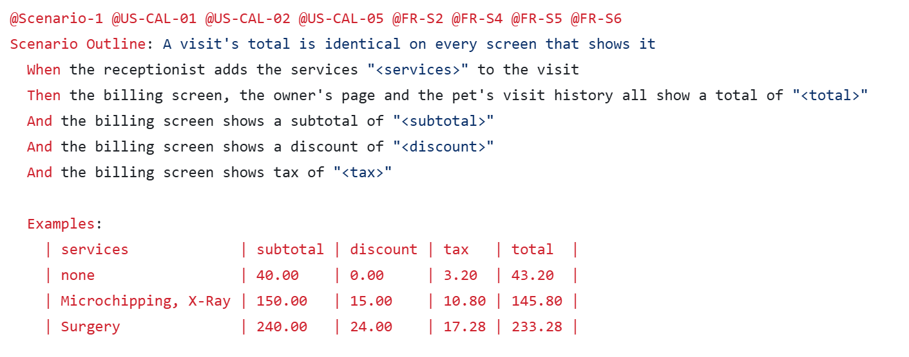
Figure 1: “A visit's total is identical on every screen that shows it” scenario
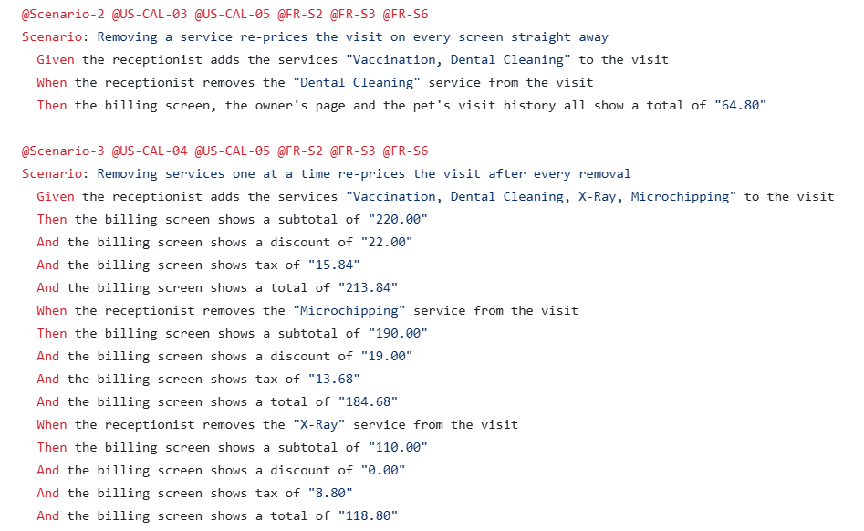
Figure 2: “Removing a service re-prices the visit on every screen straight away” scenario and “Removing services one at a time re-prices the visit after every removal” scenario

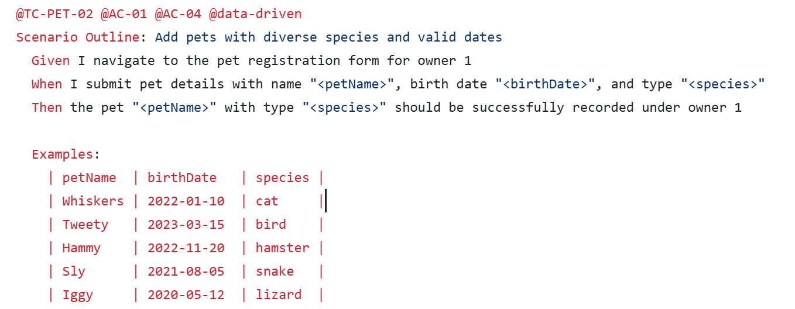
Figure 3: “Add pets with diverse species and valid dates” scenario

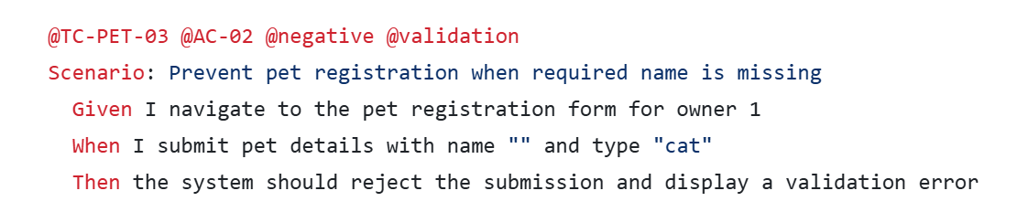
Figure 4: “Prevent pet registration when required name is missing” scenario

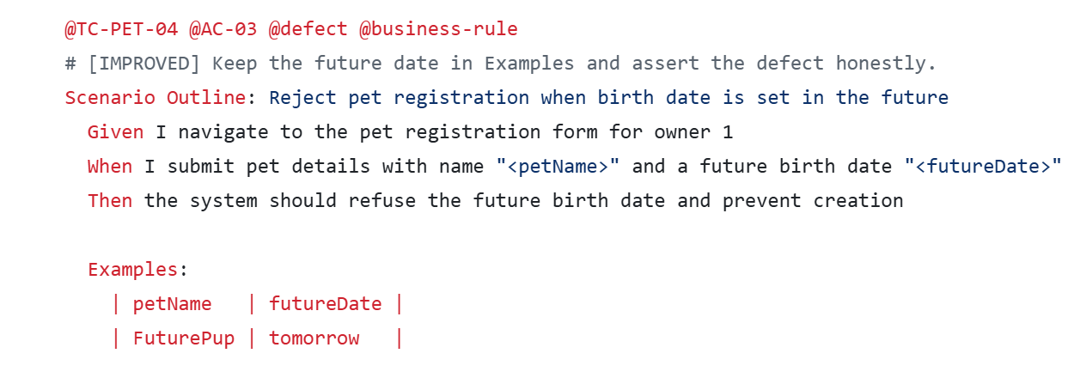
Figure 5: “Reject pet registration when birth date is set in the future” scenario

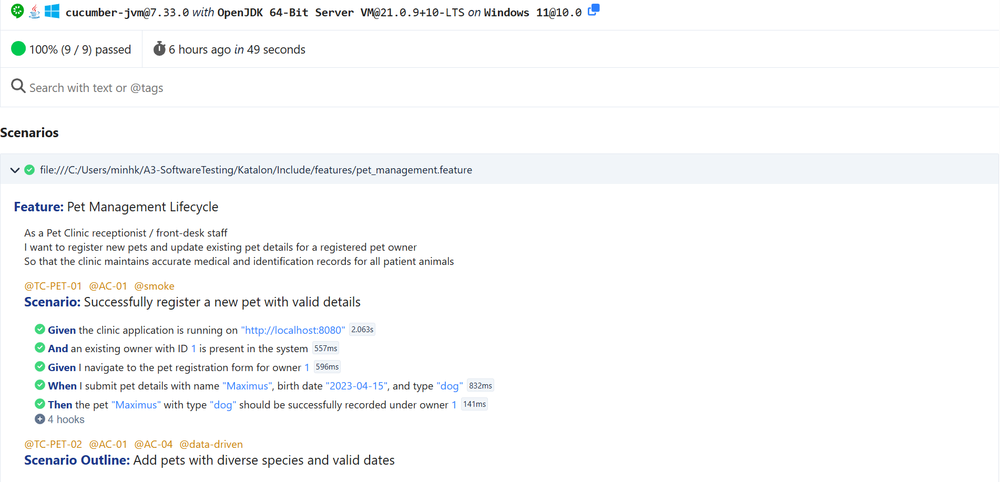
Figure 6: Pet Management Report
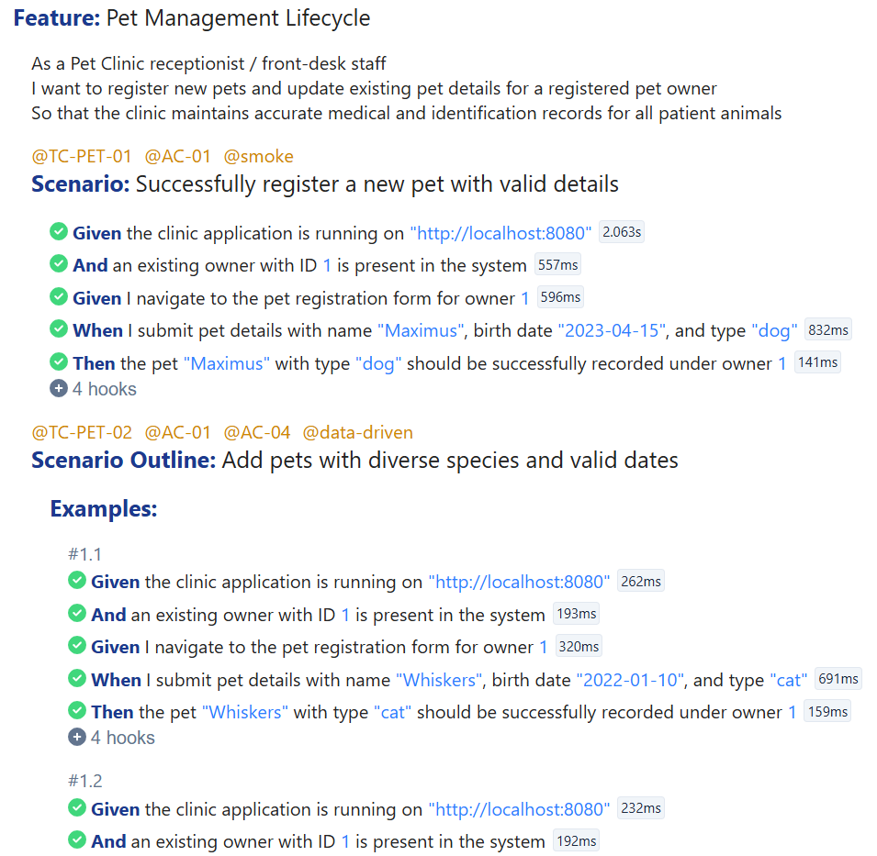

Figure 7: Pet Management Report
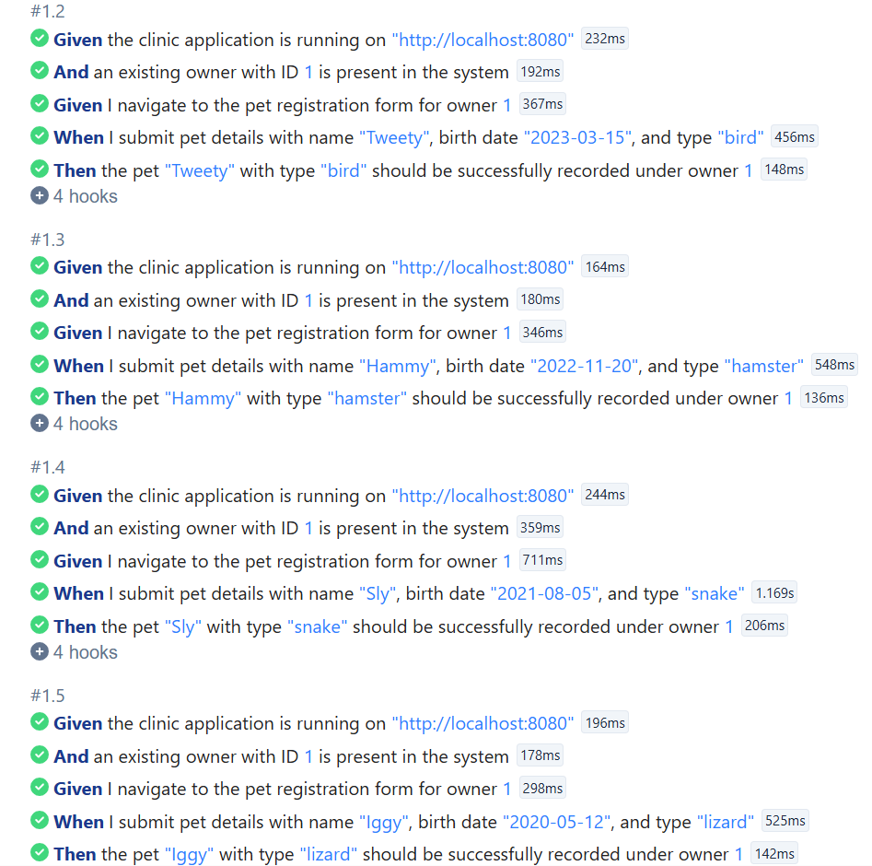
Figure 8: Pet Management Report
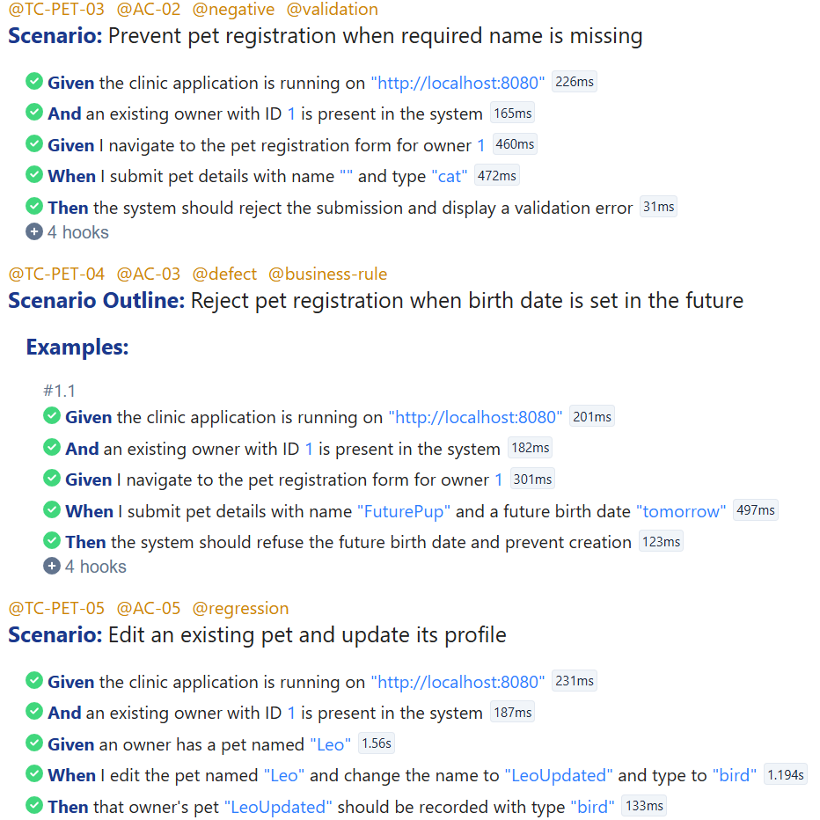
Figure 9: Pet Management Report
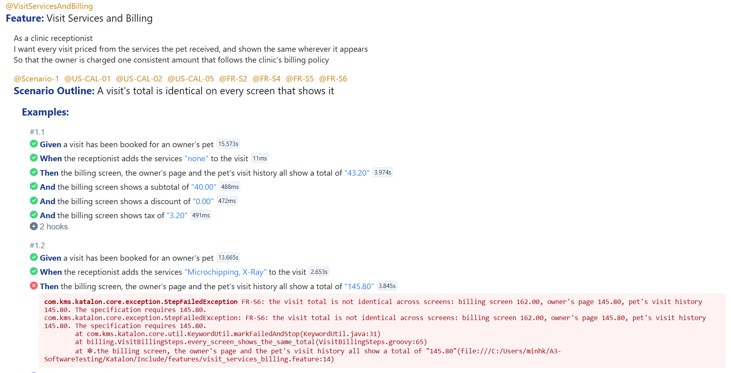
Figure 10: Visit Service and Billing Report
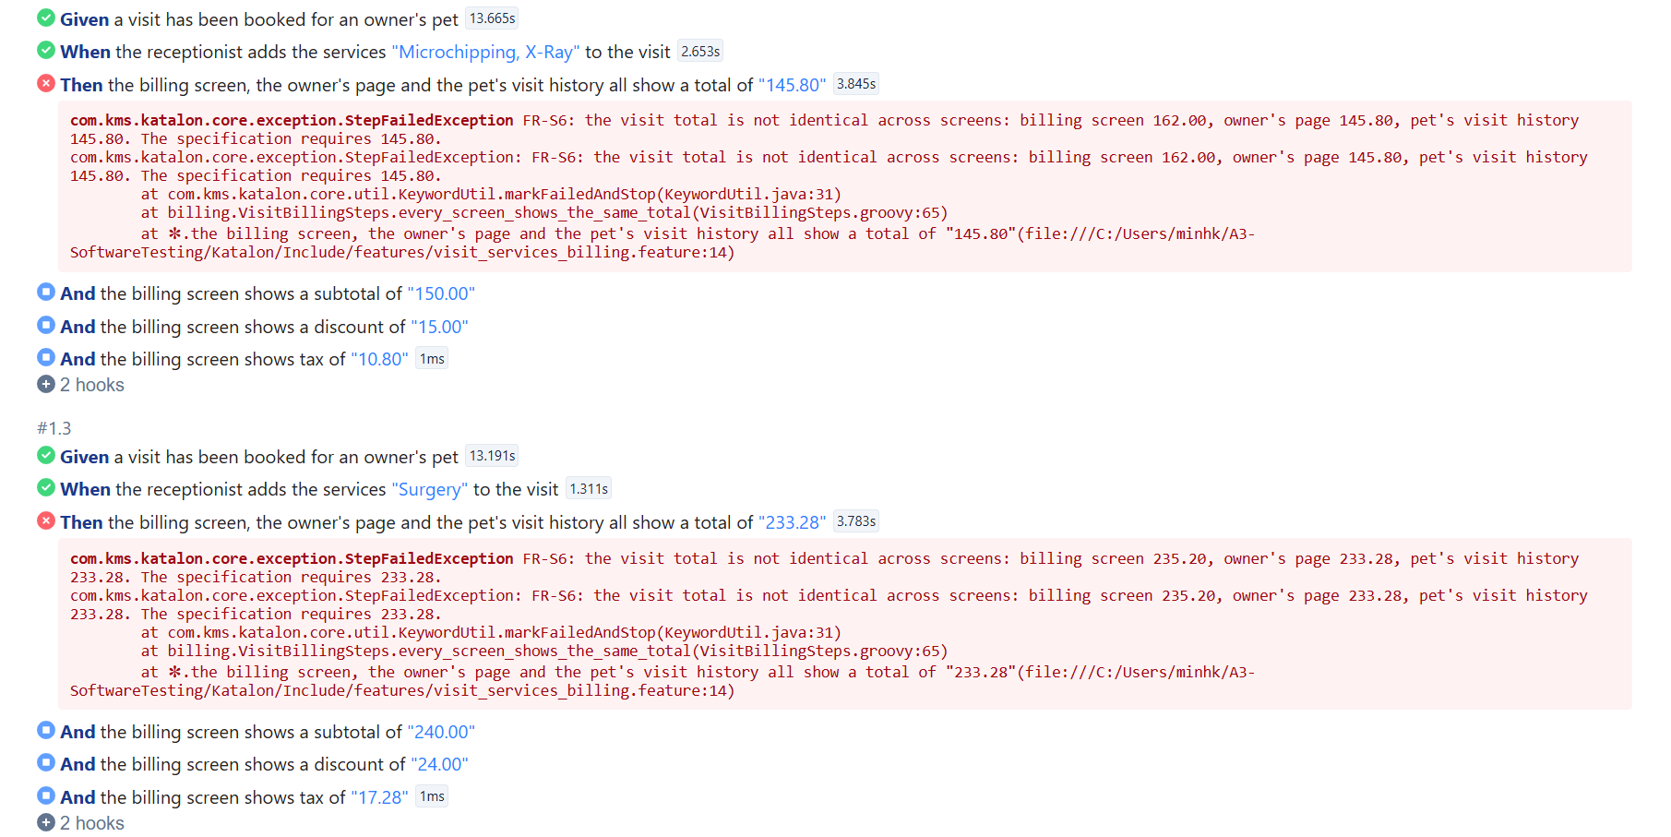
Figure 11: Pet Management Report
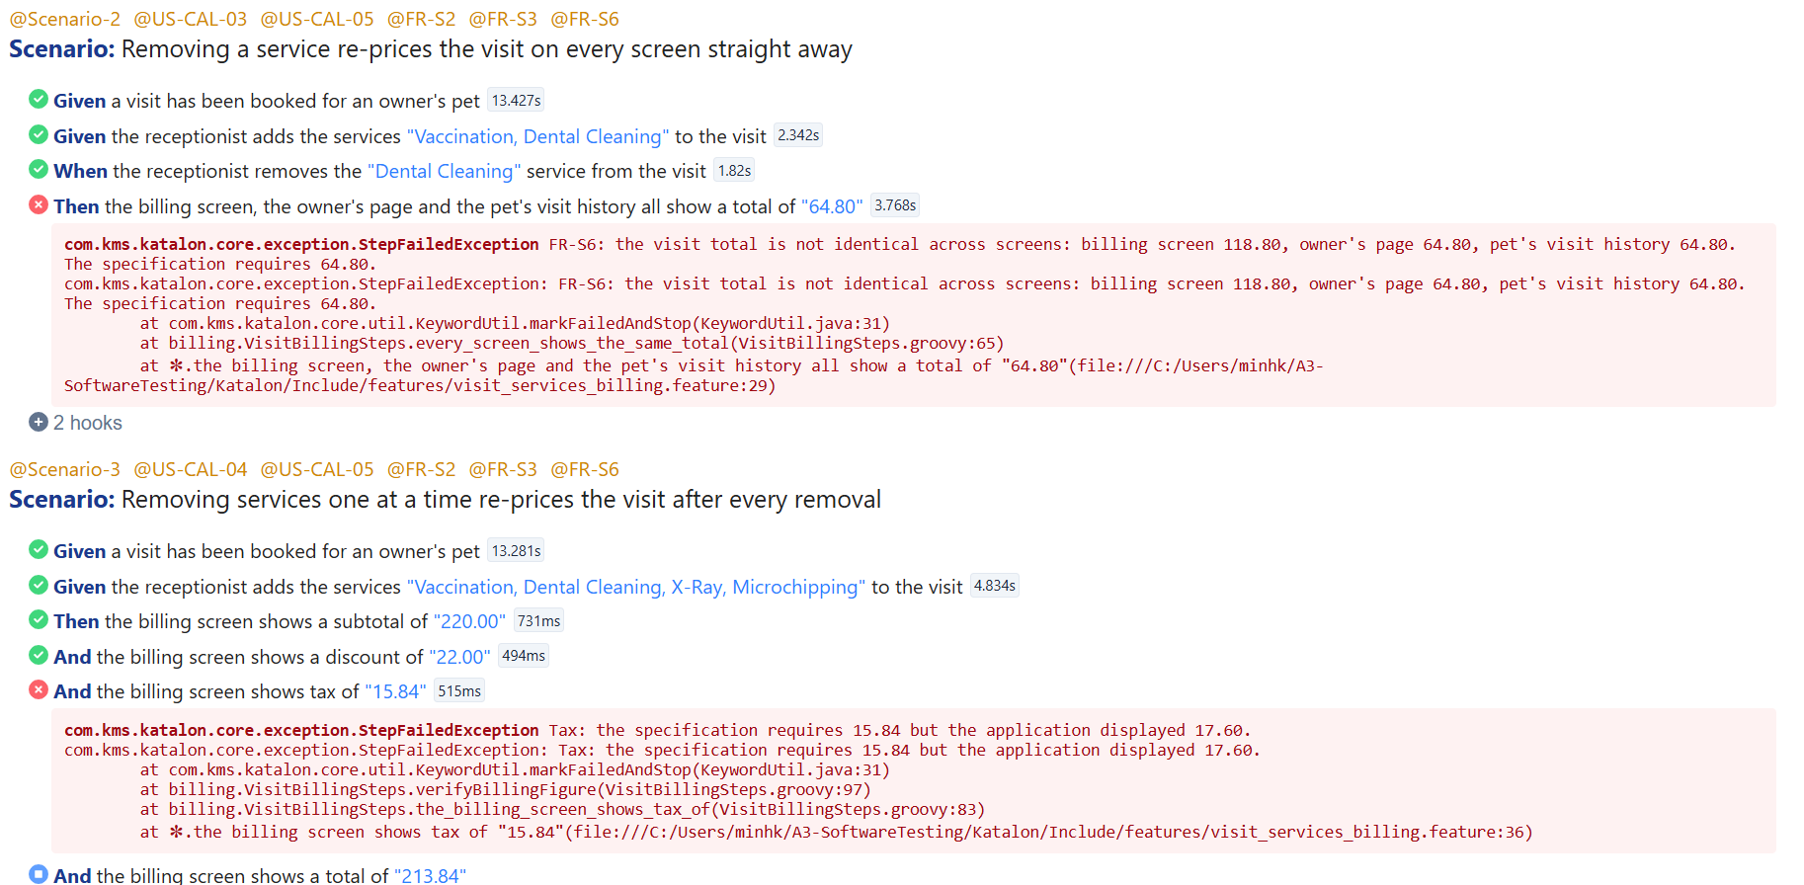
Figure 12: Pet Management Report
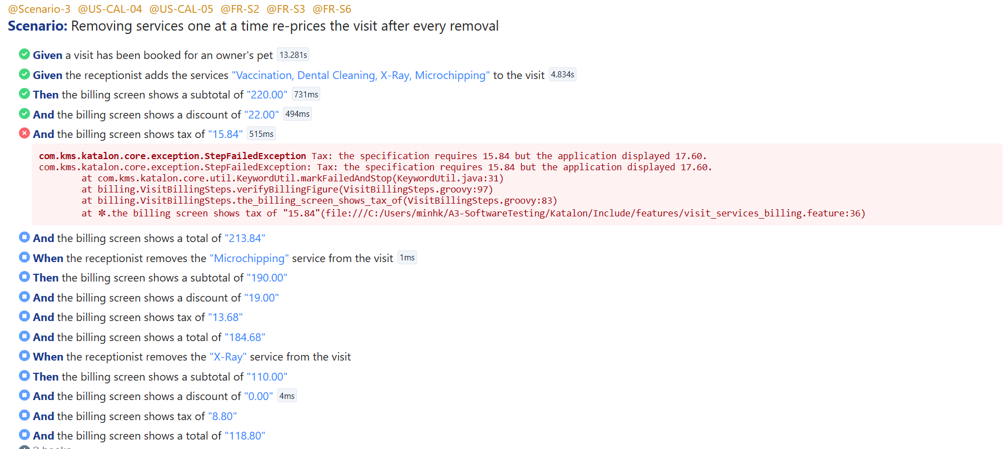
Figure 13: Pet Management Report

JMeter Complete Data Tables & Results
These tables give the full per-endpoint breakdown behind the load-level summaries reported in Section 4.3. Source: statistics.json from each run's generated HTML dashboard (html-dashboard-20260901 for the baseline plan; output_20260912-015301/html-dashboard for the advanced plan). p90/p95/p99 are the dashboard's default percentile columns.

A.1 Baseline Plan — Per-Endpoint Results by Load Level (Read-Only)
Table A.1: Baseline Read-Only Workload Per-Endpoint Performance Results
Users | Endpoint | Samples | Mean (ms) | Median (ms) | Min (ms) | Max (ms) | p90 (ms) | p95 (ms) | p99 (ms) | Error % | Throughput (req/s)
1 | 01 Welcome Page | 12 | 36.58 | 10.0 | 7 | 332 | 236.6 | 332.0 | 332.0 | 0.00% | 0.65
1 | 02 Veterinarians List | 12 | 24.42 | 16.0 | 6 | 123 | 93.0 | 123.0 | 123.0 | 0.00% | 0.66
1 | 03 Find Owners Search | 12 | 36.33 | 32.5 | 19 | 95 | 77.9 | 95.0 | 95.0 | 0.00% | 0.66
1 | 04 Owner Details | 12 | 26.83 | 28.5 | 13 | 34 | 34.0 | 34.0 | 34.0 | 0.00% | 0.67
1 | 05 Visit Billing Calculation | 11 | 22.09 | 22.0 | 9 | 43 | 40.0 | 43.0 | 43.0 | 0.00% | 0.67
10 | 01 Welcome Page | 102 | 4.34 | 3.0 | 1 | 65 | 6.0 | 10.0 | 63.5 | 0.00% | 5.18
10 | 02 Veterinarians List | 100 | 9.88 | 7.0 | 4 | 74 | 15.9 | 20.8 | 73.9 | 0.00% | 5.17
10 | 03 Find Owners Search | 98 | 15.29 | 14.0 | 6 | 89 | 22.0 | 25.1 | 89.0 | 0.00% | 5.15
10 | 04 Owner Details | 95 | 14.81 | 13.0 | 6 | 86 | 20.4 | 25.6 | 86.0 | 0.00% | 5.12
10 | 05 Visit Billing Calculation | 92 | 11.02 | 9.0 | 4 | 67 | 16.0 | 19.3 | 67.0 | 0.00% | 5.09
25 | 01 Welcome Page | 250 | 2.60 | 2.0 | 0 | 26 | 5.0 | 8.0 | 23.0 | 0.00% | 12.81
25 | 02 Veterinarians List | 247 | 6.59 | 4.0 | 2 | 48 | 14.2 | 23.2 | 42.7 | 0.00% | 12.85
25 | 03 Find Owners Search | 241 | 13.06 | 8.0 | 5 | 81 | 29.0 | 38.0 | 70.6 | 0.00% | 12.76
25 | 04 Owner Details | 234 | 12.55 | 8.0 | 4 | 75 | 28.0 | 38.0 | 70.5 | 0.00% | 12.60
25 | 05 Visit Billing Calculation | 228 | 8.77 | 6.0 | 3 | 64 | 16.0 | 28.0 | 55.7 | 0.00% | 12.50
50 | 01 Welcome Page | 505 | 1.56 | 1.0 | 0 | 31 | 2.0 | 4.0 | 8.0 | 0.00% | 25.65
50 | 02 Veterinarians List | 497 | 3.98 | 3.0 | 2 | 26 | 6.0 | 8.0 | 17.0 | 0.00% | 25.64
50 | 03 Find Owners Search | 486 | 7.52 | 6.0 | 4 | 46 | 11.0 | 15.0 | 27.3 | 0.00% | 25.47
50 | 04 Owner Details | 475 | 6.60 | 6.0 | 4 | 32 | 9.0 | 12.0 | 23.2 | 0.00% | 25.30
50 | 05 Visit Billing Calculation | 464 | 4.45 | 4.0 | 2 | 17 | 6.0 | 8.0 | 14.7 | 0.00% | 25.15
Total | All endpoints, all load levels | 4173 | 6.96 | 5.0 | 0 | 332 | 13.0 | 20.0 | 40.0 | 0.00% | 52.59

A.2 Advanced Plan — Per-Endpoint Results by Load Level (Warm-Up + Mixed Read/Write)
The warm-up thread group (TG_00_Warmup) exercised only the first 3 read endpoints, as designed. “06 Create Owner (POST)” is the write sampler introduced in the advanced plan and has no baseline equivalent.
Table A.2: Advanced Mixed Workload Per-Endpoint Performance Results
Users | Endpoint | Samples | Mean (ms) | Median (ms) | Min (ms) | Max (ms) | p90 (ms) | p95 (ms) | p99 (ms) | Error % | Throughput (req/s)
Warm-up | 01 Welcome Page | 98 | 4.76 | 4.0 | 1 | 19 | 8.0 | 12.0 | 19.0 | 0.00% | 6.76
Warm-up | 02 Veterinarians List | 98 | 11.20 | 10.0 | 4 | 34 | 19.0 | 22.1 | 34.0 | 0.00% | 6.76
Warm-up | 03 Find Owners Search | 96 | 37.05 | 37.0 | 15 | 124 | 46.3 | 47.1 | 124.0 | 0.00% | 6.72
1 | 01 Welcome Page | 8 | 5.25 | 4.5 | 2 | 12 | 12.0 | 12.0 | 12.0 | 0.00% | 0.59
1 | 02 Veterinarians List | 8 | 12.12 | 11.0 | 6 | 22 | 22.0 | 22.0 | 22.0 | 0.00% | 0.59
1 | 03 Find Owners Search | 8 | 34.00 | 33.0 | 14 | 60 | 60.0 | 60.0 | 60.0 | 0.00% | 0.59
1 | 04 Owner Details | 8 | 22.75 | 23.5 | 8 | 39 | 39.0 | 39.0 | 39.0 | 0.00% | 0.59
1 | 05 Visit Billing Calculation | 7 | 12.00 | 11.0 | 6 | 27 | 27.0 | 27.0 | 27.0 | 0.00% | 0.60
1 | 06 Create Owner (POST) | 7 | 22.71 | 22.0 | 5 | 47 | 47.0 | 47.0 | 47.0 | 0.00% | 0.60
10 | 01 Welcome Page | 71 | 2.52 | 2.0 | 1 | 9 | 5.0 | 6.0 | 9.0 | 0.00% | 4.87
10 | 02 Veterinarians List | 70 | 5.17 | 4.0 | 2 | 15 | 9.0 | 13.4 | 15.0 | 0.00% | 4.94
10 | 03 Find Owners Search | 68 | 22.18 | 18.5 | 14 | 48 | 38.4 | 43.5 | 48.0 | 0.00% | 4.91
10 | 04 Owner Details | 66 | 8.61 | 7.0 | 4 | 26 | 13.3 | 18.9 | 26.0 | 0.00% | 4.87
10 | 05 Visit Billing Calculation | 65 | 5.31 | 5.0 | 2 | 16 | 8.0 | 10.7 | 16.0 | 0.00% | 4.91
10 | 06 Create Owner (POST) | 62 | 5.27 | 4.0 | 3 | 29 | 7.0 | 11.5 | 29.0 | 0.00% | 4.84
25 | 01 Welcome Page | 177 | 1.63 | 1.0 | 0 | 26 | 2.2 | 3.0 | 14.3 | 0.00% | 12.10
25 | 02 Veterinarians List | 174 | 3.57 | 3.0 | 2 | 15 | 5.0 | 7.0 | 12.8 | 0.00% | 12.11
25 | 03 Find Owners Search | 169 | 23.72 | 21.0 | 14 | 115 | 33.0 | 41.5 | 102.4 | 0.00% | 12.06
25 | 04 Owner Details | 165 | 6.53 | 5.0 | 4 | 72 | 8.4 | 13.0 | 48.2 | 0.00% | 12.07
25 | 05 Visit Billing Calculation | 160 | 4.23 | 4.0 | 2 | 21 | 6.9 | 9.0 | 17.9 | 0.00% | 12.05
25 | 06 Create Owner (POST) | 155 | 3.93 | 3.0 | 2 | 18 | 6.0 | 8.2 | 14.1 | 0.00% | 11.89
50 | 01 Welcome Page | 331 | 2.67 | 2.0 | 0 | 18 | 6.0 | 7.0 | 12.7 | 0.00% | 22.67
50 | 02 Veterinarians List | 325 | 8.84 | 6.0 | 2 | 46 | 19.0 | 25.0 | 30.0 | 0.00% | 22.64
50 | 03 Find Owners Search | 321 | 99.68 | 67.0 | 21 | 280 | 213.0 | 237.8 | 269.8 | 0.00% | 22.75
50 | 04 Owner Details | 311 | 15.47 | 10.0 | 4 | 69 | 33.8 | 41.4 | 51.9 | 0.00% | 22.62
50 | 05 Visit Billing Calculation | 309 | 9.70 | 6.0 | 2 | 53 | 21.0 | 26.0 | 40.5 | 0.00% | 23.00
50 | 06 Create Owner (POST) | 299 | 5.29 | 4.0 | 1 | 39 | 10.0 | 14.0 | 24.0 | 0.00% | 22.88
Total | All endpoints, all load levels | 4682 | 13.73 | 4.0 | 0 | 280 | 29.0 | 45.0 | 198.0 | 0.00% | 62.81
Note: at 50 concurrent users, 03 Find Owners Search is the clear outlier — mean 99.68 ms and p95 237.8 ms, several times higher than every other endpoint at the same load level (highlighted above). The write endpoint, 06 Create Owner (POST), stays fast (5.29 ms mean, 24.0 ms p99) even at 50 users. This localises the load-level degradation reported in Section 4.4 to the owner-search query path rather than to write-lock contention from the new POST sampler.

AI Prompt History & Output Records

List of Tables
Table 1.1: Explicitly Out-of-Scope Functional Areas and Exclusion Reasons
Out-of-Scope Area | Reason for Exclusion
Real Third-Party Payment Gateways | The Release 2.0 candidate handles internal visit billing and fee calculations; external credit card transaction processing is not implemented in this build.
Production Scalability Benchmarking | The application runs as a single local process backed by an in-memory H2 database; benchmarking production infrastructure capacity is unsupported by this deployment architecture.
Cross-Browser & Multi-OS Matrix | Testing is standardized on Google Chrome and headless automated execution to maximize test automation depth across core workflows within allocated project constraints.
Security & Penetration Testing | Formal penetration testing, SQL injection vulnerability scans, and network-level security audits are excluded as the engagement focus is functional correctness, performance trends, and business rule compliance.
Table 1.2: Test Automation and Management Streams Matrix
Stream | Focus | Tools Used | Key Deliverables
Stream A: Selenium Automation | End-to-end regression testing | Java 17, Selenium WebDriver 4.27.0, JUnit 5, WebDriverManager | 5 test classes (tests.*), Page Object classes (pages.*), Surefire XML/TXT reports
Stream B: JMeter Performance | Concurrency and load assessment | Apache JMeter 5.6 | JMX test plan, CSV results (results.jtl), HTML dashboard report
Stream C: BDD Acceptance | Business rule validation | Katalon Studio, Cucumber, Gherkin | 2 feature files, step definitions, exported execution report
Test & Defect Management | Test planning and bug tracking | Jira, QAlity Plugin | 5 user stories, acceptance criteria, test execution cycles, defect reports
Table 1.3: Testing Tools and Implementation Details
Selenium WebDriver | Automated five test suites using the Page Object Model. All tests use explicit waits (WebDriverWait) rather than fixed sleeps, and use @ParameterizedTest for data-driven checks.
Apache JMeter | Performed stress tests, stimulating 1, 10, 25, and 50 concurrent users with a 10-second ramp-up and a 20-second measurement window. All tests include a 300 ms constant timer and a response assertion.
Katalon Studio | Implemented declarative Gherkin feature files covering business rules for Pet Management and Visit Billing. Scenarios include scenario outlines, negative validations, and defect checks.
Jira & QAlity | Mapped all tests back to user stories and acceptance criteria. Logged observed bugs with reproduction steps, severity ratings, and test evidence.
Table 1.4: Team Member Role and Stream Allocations
Team Member | Assigned Role & Stream
Chang Fang Cih (Caelum) | Team coordination, Pet Management (Selenium & BDD & JMeter)
Lam Quang Nhat | Owner Management tests (Selenium & BDD & JMeter)
Tran Vinh Trong | Visit Management tests (Selenium & BDD & JMeter)
Bui Phuong Dong Quan | Visit Services and Billing automation (Selenium & BDD & JMeter)
Nguyen Minh Khoi | Veterinarian Directory tests and Owner Search pagination tests (Selenium & BDD & JMeter)
Table 1.5: Engagement Milestones and Schedule
Milestone | Activities & Deliverables
Phase 1: Planning  (Week 09) | - Requirement analysis & assumption recording  - Jira user stories & QAlity test cycle setup  - Environment baseline validation & test plan sign-off
Phase 2: Test Development  (Week 10) | - Build Selenium Page Objects  - Write Katalon Gherkin scenarios  - Construct the JMeter thread groups
Phase 3: Test Execution  (Week 11) | - Run all test suites  - Record execution logs  - File Jira defects and conduct retests
Phase 4: Reporting & Submission  (Week 12) | - Release assessment against Section 1.4 exit criteria  - Final consolidated report & slide deck compilation  - Final presentation and technical Q&A delivery
Table 1.6: Project Assumptions and Risk Impact Analysis
ID | Assumption | Why We Assumed It | Risk if Incorrect
ASM-01 | The Assignment 1 Requirements Summary is the baseline standard. | The client did not provide a change log of bug fixes in Release 2.0; the original requirements remain our only functional reference. | If the client intentionally changed a business rule without updating documentation, valid behavior could be flagged as a defect.
ASM-02 | The H2 in-memory database resets when the process restarts. | Spring Boot Pet Clinic re-seeds test data into memory at every startup. | If data persisted between runs, tests could fail due to leftover state rather than code defects. Tests must create their own test fixtures.
ASM-03 | Local JMeter results evaluate relative degradation, not absolute capacity. | JMeter and the Pet Clinic application run on the same development machine, sharing CPU and RAM. | Presenting local numbers as production benchmarks would mislead the clinic regarding hardware sizing.
ASM-04 | Clinic staff uses Google Chrome on desktop monitors. | The clinic specified desktop workstations for daily front-desk operations. | Supporting legacy browsers or mobile layouts would require additional responsive design and locator testing.
ASM-05 | Team members use standardized environments. | The team uses Java 17, Chrome, Maven, WebDriverManager 5.9.2, and Katalon Studio 9.x. | Differences in OS, screen resolution, or drivers may cause flaky tests and false failures.
ASM-06 | The application has no external service dependencies. | PetClinic handles scheduling and billing internally without external APIs or third-party endpoints. | External payment, notification, or API failures are not covered by this test suite.
Table 2.1: Selenium Test Architecture and Environment Technical Specifications
Build Tool | Apache Maven (groupId: com.petclinic.testing, artifactId: petclinic-selenium)
Language / Runtime | Java 17
Test Framework | JUnit 5.11.0
Automation Library | Selenium WebDriver 4.27.0, JUnit 5 (JUnit Jupiter 5.10.2)
Driver Management | WebDriverManager 5.9.2 (automated ChromeDriver resolution and lifecycle management)
Test Class | • Feature 1 (Owner Management): tests.owner.OwnerManagementTest, tests.owner.OwnerSearchPaginationTest  • Feature 2 (Pet Registration): tests.pet.PetManagementTest  • Feature 3 (Visit Booking): tests.visit.VisitBookingTest  • Feature 4 (Services Billing): tests.billing.VisitServicesBillingTest  • Feature 5 (Vet Directory): tests.veterinarian.VeterinarianDirectoryTest
Design Pattern | Page Object Model (POM) with centralized BasePage and domain page objects (OwnerDetailsPage, PetFormPage, VisitServicesPage, VisitFixtureFlow)
Report Output | Maven Surefire Plugin 3.2.5 outputting XML and TXT test summaries to target/surefire-reports/, archived in reports/
Table 2.2: Feature 1 - Owner Management Test Execution Matrix
Test ID & Method | Linked AC | Test Type | Test Actions & Input Data | Expected Result & Verification | Result / Finding
TC-OWN-01 testAddNewOwnerSuccess | AC-01 | Positive / Smoke | Navigate to /owners/new. Input: First Name = Jean, Last Name = Coleman, Address = 110 W. Liberty St., City = Madison, Telephone = 6085551023. Click Submit. | Owner detail page is displayed at /owners/{id} showing the submitted name, address, city, and telephone exactly as entered, with a “New Owner Created” confirmation. | Passed
TC-OWN-02 testAddOwnerWithBlankFirstName | AC-02 | Negative / Validation | Navigate to /owners/new. Leave First Name blank; fill Last Name, Address, City, and Telephone with valid values. Click Submit. | Submission is blocked; a “must not be blank” error is shown next to First Name; no owner record is created. | Passed
TC-OWN-03 testAddOwnerWithBlankLastName | AC-02 | Negative / Validation | Navigate to /owners/new. Leave Last Name blank; fill the remaining fields with valid values. Click Submit. | Submission is blocked with a “must not be blank” error next to Last Name; no owner record is created. | Passed
TC-OWN-04 testAddOwnerWithBlankAddress | AC-02 | Negative / Validation | Navigate to /owners/new. Leave Address blank; fill the remaining fields with valid values. Click Submit. | Submission is blocked with a “must not be blank” error next to Address; no owner record is created. | Passed
TC-OWN-05 testAddOwnerWithBlankCity | AC-02 | Negative / Validation | Navigate to /owners/new. Leave City blank; fill the remaining fields with valid values. Click Submit. | Submission is blocked with a “must not be blank” error next to City; no owner record is created. | Passed
TC-OWN-06 testFirstNameExceedsMaxLengthRejected | AC-02 | Negative / Boundary | Navigate to /owners/new. Input a 31-character First Name (one character past the specified 30-character limit); fill the remaining fields with valid values. Click Submit. | Submission is blocked with a field-level validation error; no owner record is created. | Passed
TC-OWN-07 / 08 / 09 tcOwn02to04_telephoneBoundaryValuesRejected (@ParameterizedTest, @CsvSource, 5 rows) | AC-03 | Negative / Boundary (Data-Driven) | 5 iterations against /owners/new, all other fields valid: 1. Telephone = 608555102 (9 digits) 2. Telephone = 60855510234 (11 digits) 3. Telephone = 60855510A3 (non-digit character) 4. Telephone = “” (blank) 5. Telephone = 6085551023 (exactly 10 digits, valid) | Rows 1–4 are rejected with “Telephone must be a 10-digit number” (or “must not be blank” for row 4) and no owner is saved. Row 5 is accepted and the owner is created. | Passed (all 5 assertions passed
TC-OWN-10 testEditOwnerDetailsSuccess | AC-06 | Positive / Regression / Mutation | Navigate to an existing owner's edit form. Update Address and Telephone to new valid values. Click Submit. | Browser returns to /owners/{id}; the updated address and telephone persist on the detail page; an “Owner Values Updated” message is shown; the owner identifier is unchanged. | Passed
TC-OWN-11 testOwnerDetailPageDisplaysPetsAndVisits | AC-05 | Positive / Smoke | Navigate to /owners/{id} for a seeded owner with at least one pet and one billed visit. | The detail page shows the owner's contact details, every pet belonging to that owner, and each pet's visit history including the billed total per visit. | Passed
TC-OWN-12 testEditOwnerRejectsBlankRequiredField | AC-06 | Negative / Validation | Navigate to an existing owner's edit form. Clear the Address field and leave the rest unchanged. Click Submit. | The same required-field validation used on creation is applied on edit; a “must not be blank” error is shown and the existing record is not overwritten. | Passed
TC-OWN-13 frO4_ownerSearchShouldBeCaseInsensitive | AC-04 | Defect Detection | Navigate to /owners/find. Search using an uppercase variant and then a lowercase variant of a last name known to exist in the seed data (e.g. “DAVIS” and “davis”). Click Find Owner for each. | Per FR-O4, the search should match the stored last name case-insensitively regardless of the case entered. | Failed  both the uppercase and lowercase variants return a “has not been found” error even though the owner exists; only the exact stored case returns a match. (Defect BUG-OWN-01)
TC-OWN-14 frPg1_ownerListShouldShowFiveOwnersPerPage | AC-08 | Defect Detection | Navigate to /owners/find with a blank Last Name to return every seeded owner (more than one page's worth). Count the owner rows rendered on the first results page. | Per FR-PG1, exactly 5 owners should be shown per page, with First, Previous, page number, Next, and Last navigation. | Failed  the results page renders 6 owner rows before breaking to the next page. (Defect BUG-OWN-02)
Table 2.3: Feature 2 - Pet Registration & Editing Test Execution Matrix
Test ID & Method | Linked AC | Test Type | Test Actions & Input Data | Expected Result & Verification | Result / Finding
TC-PET-02  testDataDrivenAddPet | AC-01  AC-04 | Data-Driven (@ParameterizedTest) | Navigate to /owners/2/pets/new. Execute 5 iterations via @CsvSource with unique, timestamped names:  1. Whiskers, 2022-01-10, cat  2. Tweety, 2023-03-15, bird  3. Hammy, 2022-11-20, hamster  4. Sly, 2021-08-05, snake  5. Iggy, 2020-05-12, lizard | Each species selection from the dropdown is accepted and rendered accurately on the owner profile without value truncation or mapping errors. | Passed
TC-PET-03  testAddPetWithBlankNameValidation | AC-02 | Negative / Validation | Navigate to /owners/1/pets/new.  Input: Name = "" (empty), Birth Date = 2023-01-01, Type = dog. Click Submit. | Submission is blocked. Page URL remains /owners/1/pets/new and a visible field validation error is displayed. | Passed
TC-PET-04  testFutureBirthDateBehavior | AC-03 | Defect Detection | Navigate to /owners/1/pets/new.  Input: Name = FuturePup, Birth Date = tomorrow (LocalDate.now().plusDays(1)), Type = dog. Click Submit. | The form should reject the future date and remain on the form with an error message; no pet record should be created. | Failed  (Defect BUG-PET-01: SUT accepted future date and saved the record)
Table 2.3: Feature 3 - Visit Booking and Management Test Execution Matrix
Test ID & Method | Linked AC | Test Type | Test Actions & Input Data | Expected Result & Verification | Result / Finding
TC-VISIT-01 (SCRUM-64) — Reject visit dated today | AC-1.1 (FR-V2) | Negative / Validation | Navigate to Add Visit for the pet. Set Date = today. Enter a valid Description. Submit. | Validation error shown; visit is not saved. | Passed
TC-VISIT-02 (SCRUM-65) — Accept visit dated tomorrow | AC-1.2 (FR-V2 boundary) | Positive / Boundary | Navigate to Add Visit. Set Date = tomorrow. Enter a valid Description. Submit. | Visit is saved successfully; appears in the pet's visit history. | Passed
TC-VISIT-03 (SCRUM-66) — Reject empty description | AC-1.3 (FR-V3) | Negative / Validation | Navigate to Add Visit. Set Date = a valid future date. Leave Description empty. Submit. | Validation error shown; visit is not saved. | Passed
Table 2.4: Feature 4 - Services Billing & Financial Calculation Test Execution Matrix
Test ID & Method | Linked AC | Test Type | Test Actions & Input Data | Expected Result & Verification | Result / Finding
TC-CAL-01  discountThresholdBoundary | AC-02, AC-03, AC-04, AC-05 | Functional · Boundary value | Add no services. Subtotal = 40.00. | Selected Services empty. Subtotal 40.00, Discount 0.00, Tax 3.20, Total 43.20. | Passed
TC-CAL-02  discountThresholdBoundary | AC-01, AC-03, AC-04, AC-05 | Functional · Boundary value | Add Microchipping + X-Ray. Subtotal = 150.00. | Subtotal 150.00, Discount 15.00, Tax 10.80, Total 145.80 | Failed
TC-CAL-03  discountThresholdBoundary | AC-01, AC-03, AC-04, AC-05 | Functional · Boundary value | Add Surgery. Subtotal = 240.00. | Subtotal 240.00, Discount 24.00, Tax 17.28, Total 233.28 | Failed
TC-CAL-04  taxIsChargedOnPostDiscountAmount | AC-02, AC-03, AC-04, AC-05 | Functional · Equivalence partition | Add no services. Subtotal = 40.00. | Selected Services empty. Subtotal 40.00, Discount 0.00, Tax 3.20, Total 43.20. | Passed
TC-CAL-05  taxIsChargedOnPostDiscountAmount | AC-01, AC-03, AC-04, AC-05 | Functional · Equivalence partition | Add Microchipping + X-Ray. Subtotal = 150.00. | Subtotal 150.00, Discount 15.00, Tax 10.80, Total 145.80 | Failed
TC-CAL-06  taxIsChargedOnPostDiscountAmount | AC-01, AC-03, AC-04, AC-05 | Functional · Equivalence partition | Add Surgery. Subtotal = 240.00. | Subtotal 240.00, Discount 24.00, Tax 17.28, Total 233.28 | Failed
TC-CAL-07  removeSingleServiceRecalculatesBreakdown | AC-01, AC-02, AC-03, AC-04, AC-05 | Functional · Regression | Add Vaccination + Dental Cleaning (110.00 / 0.00 / 8.80 / 118.80). Remove Dental Cleaning. | Dental Cleaning leaves Selected and returns to the Service Catalog. Subtotal 60.00, Discount 0.00, Tax 4.80, Total 64.80. | Failed
TC-CAL-08  removeMultipleServicesSequentially | AC-01, AC-02, AC-03 | Functional · Regression | Add Vaccination + Dental Cleaning + X-Ray + Microchipping (220.00). Remove Microchipping, then remove X-Ray. | Before: 220.00 / 22.00 / 15.84 / 213.84. After 1st removal: 190.00 / 19.00 / 13.68 / 184.68. After 2nd: 110.00 / 0.00 / 8.80 / 118.80 | Failed
TC-CAL-09  removeServiceAtDiscountThresholdDropsDiscount | AC-01, AC-02, AC-03, AC-04, AC-05 | Functional · Boundary value | Add Microchipping + X-Ray (150.00 / 15.00 / 10.80 / 145.80). Remove X-Ray. | Microchipping leaves Selected. Subtotal 120.00, Discount 0.00, Tax 9.60, Total 129.60 | Failed
TC-CAL-10  removeSingleServiceRecalculatesBreakdown | AC-01, AC-02, AC-03, AC-04, AC-05 | Functional · Regression | Add Surgery + X-Ray (320.00). Remove X-Ray. | Subtotal 240.00, Discount 24.00 and not the stale 32.00 (assertNotEquals), Tax 17.28, Total 233.28 | Failed
Table 2.4: Feature 4 - Services Billing & Financial Calculation Test Execution Matrix
Test ID & Method | Linked AC | Test Type | Test Actions & Input Data | Expected Result & Verification | Result / Finding
TC-CAL-01  discountThresholdBoundary | AC-02, AC-03, AC-04, AC-05 | Functional · Boundary value | Add no services. Subtotal = 40.00. | Selected Services empty. Subtotal 40.00, Discount 0.00, Tax 3.20, Total 43.20. | Passed
TC-CAL-02  discountThresholdBoundary | AC-01, AC-03, AC-04, AC-05 | Functional · Boundary value | Add Microchipping + X-Ray. Subtotal = 150.00. | Subtotal 150.00, Discount 15.00, Tax 10.80, Total 145.80 | Failed
TC-CAL-03  discountThresholdBoundary | AC-01, AC-03, AC-04, AC-05 | Functional · Boundary value | Add Surgery. Subtotal = 240.00. | Subtotal 240.00, Discount 24.00, Tax 17.28, Total 233.28 | Failed
TC-CAL-04  taxIsChargedOnPostDiscountAmount | AC-02, AC-03, AC-04, AC-05 | Functional · Equivalence partition | Add no services. Subtotal = 40.00. | Selected Services empty. Subtotal 40.00, Discount 0.00, Tax 3.20, Total 43.20. | Passed
TC-CAL-05  taxIsChargedOnPostDiscountAmount | AC-01, AC-03, AC-04, AC-05 | Functional · Equivalence partition | Add Microchipping + X-Ray. Subtotal = 150.00. | Subtotal 150.00, Discount 15.00, Tax 10.80, Total 145.80 | Failed
TC-CAL-06  taxIsChargedOnPostDiscountAmount | AC-01, AC-03, AC-04, AC-05 | Functional · Equivalence partition | Add Surgery. Subtotal = 240.00. | Subtotal 240.00, Discount 24.00, Tax 17.28, Total 233.28 | Failed
TC-CAL-07  removeSingleServiceRecalculatesBreakdown | AC-01, AC-02, AC-03, AC-04, AC-05 | Functional · Regression | Add Vaccination + Dental Cleaning (110.00 / 0.00 / 8.80 / 118.80). Remove Dental Cleaning. | Dental Cleaning leaves Selected and returns to the Service Catalog. Subtotal 60.00, Discount 0.00, Tax 4.80, Total 64.80. | Failed
TC-CAL-08  removeMultipleServicesSequentially | AC-01, AC-02, AC-03 | Functional · Regression | Add Vaccination + Dental Cleaning + X-Ray + Microchipping (220.00). Remove Microchipping, then remove X-Ray. | Before: 220.00 / 22.00 / 15.84 / 213.84. After 1st removal: 190.00 / 19.00 / 13.68 / 184.68. After 2nd: 110.00 / 0.00 / 8.80 / 118.80 | Failed
TC-CAL-09  removeServiceAtDiscountThresholdDropsDiscount | AC-01, AC-02, AC-03, AC-04, AC-05 | Functional · Boundary value | Add Microchipping + X-Ray (150.00 / 15.00 / 10.80 / 145.80). Remove X-Ray. | Microchipping leaves Selected. Subtotal 120.00, Discount 0.00, Tax 9.60, Total 129.60 | Failed
TC-CAL-10  removeSingleServiceRecalculatesBreakdown | AC-01, AC-02, AC-03, AC-04, AC-05 | Functional · Regression | Add Surgery + X-Ray (320.00). Remove X-Ray. | Subtotal 240.00, Discount 24.00 and not the stale 32.00 (assertNotEquals), Tax 17.28, Total 233.28 | Failed

Table 2.5: Feature 5 - Veterinarian Directory & Search Test Execution Matrix
Test ID & Method | Linked AC | Test Type | Test Actions & Input Data | Expected Result & Verification | Result / Finding
TC-VET-01  testVeterinarianDirectoryWithoutSpecialities | AC-02 | Positive / Edge Case | Navigate to /vets/html.  Locate a veterinarian row with no specialty badges. | At least one veterinarian is displayed with no specialty and no error is shown. | Passed
TC-SEARCH-01  emptySearchReturnsAllOwners | AC-03 | Positive / Smoke | Navigate to /owners/find.  Leave Lastname blank.  Click Find Owner | All owners are displayed in the Owner table. | Passed
TC-SEARCH-02  searchWithNoMatchOwner | AC-02 | Negative / Validation | Navigate to /owners/find.  Input: lastname = “Nguyen” (no owners are registered under this lastname).  Click Find Owner | A “has not been found” message is shown when clicking the Find Owner button, no owner list shown. | Passed
TC-SEARCH-03  searchWithOnlyOneMatchOwner | AC-04 | Positive / Smoke | Navigate to /owners/find.  Input: lastname = “Franklin”.  Click Find Owner | Browse redirects directly to /owners/{id} for the matching owner. | Passed
TC-SEARCH-04  searchWithMultipleMatchOwner | AC-05 | Positive / Smoke | Navigate to /owners/find.  Input: lastname = “Davis”.  Click Find Owner | Matching owner pagination list is shown. | Passed
TC-SEARCH-05  searchIsCaseInsensitive | AC-01 | Data Driven | Navigate to /owners/find.  Execute iterations via @CsvSource:  - Davis  - davis | Each case should direct to the owner table page with a matching lastname. | Failed  lowercase input did not return the same result (“has not been found” message is shown).
TC-PAGINATION-01  testVetListPagination | AC-03 | Positive / Functional | Navigate to /vets.html.  Click Next button | URL updates to reflect page 2, pagination list advances correctly | Passed
TC-PAGINATION-02  testOwnerListPagination | AC-03 | Positive / Functional | Navigate to /owners/find.  Leave Lastname blank.  Click Find Owner  Click Next button | URL updates to reflect page 2, pagination list advances correctly | Passed
Table 3.1: BDD Test Scenarios Overview and Objectives
Feature | Scenario | Type | Purpose
Visit Services and Billing | A visit's total is identical on every screen that shows it | Scenario Outline | Verify Total consistency across pages
Visit Services and Billing | Removing a service re-prices the visit on every screen straight away | Positive | Verify recalculation after removing a service
Visit Services and Billing | Removing services one at a time re-prices the visit after every removal | Positive | Verify recalculation after removing multiple services
Pet Management | Successfully register a new pet with valid details | Positive | Verify a new pet is registered successfully with valid details
Pet Management | Add pets with diverse species and valid dates | Scenario Outline | Verify a new pet is registered successfully with valid species and dates
Pet Management | Prevent pet registration when required name is missing | Negative | Verify an error is shown when pet’s name is empty
Pet Management | Reject pet registration when birth date is set in the future | Negative | Verify pet registration boundary rules reject future birth dates
Pet Management | Edit an existing pet and update its profile | Positive | Verify pet’s name and species are changed after editing
Table 3.2: Traceability Matrix of BDD Scenarios to Acceptance Criteria and User Stories
Feature | Scenario | Acceptance Criteria | User Story
Visit Services and Billing | A visit's total is identical on every screen that shows it | US-CAL-01: AC-01, AC-02, AC-03, AC-04  US-CAL-02: AC-01, AC-02, AC-04  US-CAL-05: AC-01, AC-02 | US-CAL-01, US-CAL-02, US-CAL-05
Visit Services and Billing | Removing a service re-prices the visit on every screen straight away | US-CAL-03: AC-01, AC-02, AC-03, AC-04, AC-05  US-CAL-05: AC-01, AC-03 | US-CAL-03, US-CAL-05
Visit Services and Billing | Removing services one at a time re-prices the visit after every removal | US-CAL-04: AC-01, AC-02, AC-03  US-CAL-05: AC-02, AC-03 | US-CAL-04, US-CAL-05
Pet Management | Successfully register a new pet with valid details | AC-01 | US-PET-02
Pet Management | Add pets with diverse species and valid dates | AC-01, AC-04 | US-PET-02
Pet Management | Prevent pet registration when required name is missing | AC-02 | US-PET-02
Pet Management | Reject pet registration when birth date is set in the future | AC-03 | US-PET-02
Pet Management | Edit an existing pet and update its profile | AC-05 | US-PET-02
Table 4.1: Local Test Environment Hardware Baseline Specifications
Item | Value
SUT | A3-Testing-Site.jar (SHA-256 7246e232...0a9f9eb)
Target endpoint | http://localhost:8080
Execution time | 2026-09-01 18:17:18 CST
JMeter | Apache JMeter 5.6.3
Java | OpenJDK 21.0.12.1, JMeter max heap 1 GB
Load generator / OS | Apple Silicon macOS, aarch64, 8 available processors
Network topology | JMeter and the SUT ran on the same machine over loopback (localhost)
Table 4.2: Baseline Test Plan Configuration Settings
Setting | Value
Load levels | 1, 10, 25, 50 virtual users, run in separate, serialized thread groups (serialize_threadgroups=true) so results are attributable to one load level at a time
Ramp-up | 10 seconds per thread group
Scheduler duration | 20 seconds per thread group
Loop controller | Forever, bounded by the 20-second scheduler
Think time | Constant Timer, 300 ms before every request
Workload | 100% read — 5 GET endpoints per iteration
Endpoints covered | /, /vets.html, /owners?lastName=, /owners/6, /owners/6/pets/7/visits/1/services
Assertions | One Response Assertion per sampler, checking page content — an HTTP 200 alone is not accepted as a pass
Error handling | Continue on error
Listeners | View Results Tree, Aggregate Report, Summary Report, Graph Results
Raw evidence | results.jtl (CSV)
Table 5.1: US-OWN-01: Verify previously reported telephone boundary defect remains fixed
US-OWN-01: Verify previously reported telephone boundary defect remains fixed | As a clinic receptionist,  I want the system to reject phone numbers that aren't exactly 10 digits when I add or edit an owner,  so that I don't accidentally save a client's contact number that's actually unreachable.
Acceptance Criteria | • AC-01 (9-Digit Telephone Rejected): Given a 9-digit telephone number, when the form is submitted, the submission must be rejected and a validation error displayed.  • AC-02 (10-Digit Telephone Accepted): Given a 10-digit telephone number, when the form is submitted, the owner must be saved successfully.  • AC-03 (11-Digit Telephone Rejected): Given an 11-digit telephone number, when the form is submitted, the submission must be rejected and a validation error displayed.  • AC-04 (Non-Digit Character Rejected): Given a telephone number containing a non-digit character, when the form is submitted, the submission must be rejected and a validation error displayed.
Related Requirements | FR-O3 | Epic: Owner Management Workflow (SCRUM-45)
Table 5.2: US-OWN-02: Edit an owner's details
US-OWN-02: Edit an owner's details | As a front desk staff member,  I want to correct an owner's details,  so that records stay accurate over time.
Acceptance Criteria | • AC-01 (Same Validation as Create): Given a front desk staff member is editing an owner's details, when the form is submitted, the same field validation rules that apply when creating an owner must apply.  • AC-02 (Owner ID Consistency): Given an owner edit is submitted, when the owner ID in the form does not match the ID in the address, the submission must be rejected.
Related Requirements | FR-O6 | Epic: Owner Management Workflow (SCRUM-45)
Table 5.3: US-PET-01: Pet Management (SCRUM-7)
US-PET-01: Pet Management | As a Pet Clinic receptionist / front-desk staff,  I want to register new pets and update existing pet details for a registered pet owner,  so that the clinic maintains accurate medical and identification records for all patient animals.
Acceptance Criteria | • AC-01 (Successful Registration): Given a registered pet owner exists, when the receptionist submits valid pet details (Name, Birth Date, and Pet Type), the pet must be added to the owner's profile and displayed on the Owner Details page.  • AC-02 (Mandatory Field Validation): When attempting to add or edit a pet with a blank Name, the system must prevent submission and display a validation error message (e.g. "is required").  • AC-03 (Birth Date Validation): The system must validate the pet's birth date format (YYYY-MM-DD). The birth date cannot be in the future. Entering a future date must display an error message and block submission.  • AC-04 (Pet Type Selection): The receptionist must be able to select from valid pet types (cat, dog, bird, hamster, lizard, snake) from a dropdown menu.  • AC-05 (Update Existing Pet): When the receptionist edits an existing pet's details and clicks "Update Pet", the updated information must immediately reflect on the Owner Details page.
Related Requirements | Epic: Pet Management Workflow (SCRUM-46)
Table 5.3: US-PET-01: Pet Management (SCRUM-7)
US-PET-01: Pet Management | As a Pet Clinic receptionist / front-desk staff,  I want to register new pets and update existing pet details for a registered pet owner,  so that the clinic maintains accurate medical and identification records for all patient animals.
Acceptance Criteria | • AC-01 (Successful Registration): Given a registered pet owner exists, when the receptionist submits valid pet details (Name, Birth Date, and Pet Type), the pet must be added to the owner's profile and displayed on the Owner Details page.  • AC-02 (Mandatory Field Validation): When attempting to add or edit a pet with a blank Name, the system must prevent submission and display a validation error message (e.g. "is required").  • AC-03 (Birth Date Validation): The system must validate the pet's birth date format (YYYY-MM-DD). The birth date cannot be in the future. Entering a future date must display an error message and block submission.  • AC-04 (Pet Type Selection): The receptionist must be able to select from valid pet types (cat, dog, bird, hamster, lizard, snake) from a dropdown menu.  • AC-05 (Update Existing Pet): When the receptionist edits an existing pet's details and clicks "Update Pet", the updated information must immediately reflect on the Owner Details page.
Related Requirements | Epic: Pet Management Workflow (SCRUM-46)
Table 5.4: US-VISIT-01: Visit Date Validation (SCRUM-16)
US-VISIT-01: Visit Date Validation | As front desk staff,  when booking a visit, I want the system to reject visits dated today or earlier,  so that only valid future appointments are recorded.
Acceptance Criteria | • Given I am booking a visit, when I set the date to today, then the system rejects it with a validation error and does not save the visit. (FR-V2)  • Given I am booking a visit, when I set the date to tomorrow, then the visit is saved successfully. (FR-V2 boundary)  • Given I am booking a visit, when I leave the description empty, then the system rejects it with a validation error. (FR-V3)
Related Requirements | FR-V2, FR-V3 | Epic: Visit Management and Services Workflow (SCRUM-47)
Table 5.5: US-CAL-01: Handle $150 Discount Threshold Visits (SCRUM-93)
US-CAL-01: Handle $150 Discount Threshold Visits | As a Pet Clinic receptionist / front-desk staff,  I want the system to correctly apply the loyalty discount when a customer's visit reaches the $150 threshold,  so that regular customers who get multiple services receive their deserved discount without me having to manually apply it or worry about errors.
Acceptance Criteria | • AC-01 (Discount Triggers at $150): When a visit's subtotal reaches exactly $150.00 or more, the system must automatically apply a 10% loyalty discount, with no manual action required.  • AC-02 (No Discount Below $150): When a visit's subtotal is $149.99 or less, the system shows a $0.00 discount.  • AC-03 (Display Discount Clearly): The billing screen shows the discount amount (e.g. "$15.00") and the discount percentage (e.g. "10%").  • AC-04 (Correct Total for Customer Quote): The total shown on screen is the amount the customer pays. A $150.00 subtotal results in $145.80 with discount and tax, not $162.00.  • AC-05 (Predictable & Trustworthy): The discount behaves identically every time, so staff can promise "if your bill reaches $150, you get 10% off" with confidence.
Related Requirements | Epic: Billing and Financial Calculations Workflow (SCRUM-48) | Defect: DEF-CAL-02 (SCRUM-111)
Table 5.6: US-CAL-02: Calculate Tax Correctly on Discounted Amount (SCRUM-94)
US-CAL-02: Calculate Tax Correctly on Discounted Amount | As a Pet Clinic receptionist / front-desk staff,  I want the system to calculate tax by applying it to the discounted amount rather than the full bill,  so that customers are not overcharged by extra tax they shouldn't owe.
Acceptance Criteria | • AC-01 (Tax on Post-Discount Amount): When a discount is applied, tax must be calculated on the post-discount amount. Subtotal $240.00 with a $24.00 discount gives 8% of $216.00 = $17.28, not 8% of $240.00 = $19.20.  • AC-02 (Tax Calculation Without Discount): When there is no discount (subtotal below $150.00), tax is calculated on the subtotal. Subtotal $100.00 gives tax of $8.00.  • AC-03 (Display Tax Calculation Method): The system clearly shows which amount the tax is based on, e.g. "Tax (8% of $216.00): $17.28" rather than the pre-discount figure.  • AC-04 (Total Uses Correct Tax): The final Total must use the correctly calculated tax, i.e. Total = Post-Discount Amount + Tax.  • AC-05 (Consistency in All Visits): Every visit, regardless of service combination, calculates tax the same way — on the post-discount amount when a discount applies, otherwise on the subtotal.
Related Requirements | Epic: Billing and Financial Calculations Workflow (SCRUM-48) | Defect: DEF-CAL-03 (SCRUM-112)
Table 5.7: US-CAL-03: Remove Service from Visit (SCRUM-113)
US-CAL-03: Remove Service from Visit | As a Pet Clinic receptionist / front-desk staff,  I want to remove a service from a visit,  so that I can correct mistakes or adjust services before saving.
Acceptance Criteria | • AC-01 (Remove Service from List): Clicking "Remove" next to a selected service makes it disappear immediately from the Selected Services list, and it is no longer shown anywhere.  • AC-02 (Immediate Recalculation): Removing a service immediately recalculates subtotal, discount, tax, and total.  • AC-03 (Immediate Display Update): All billing values redisplay immediately after removal, with no page refresh needed.  • AC-04 (Correct New Values): The new values are mathematically correct for the remaining services.  • AC-05 (No Data Loss): Removing one service does not affect other services, which remain selected and visible.
Related Requirements | Epic: Billing and Financial Calculations Workflow (SCRUM-48) | Defect: DEF-CAL-04 (SCRUM-123)
Table 5.8: US-CAL-04: Remove Multiple Services One by One (SCRUM-114)
US-CAL-04: Remove Multiple Services One by One | As a Pet Clinic receptionist / front-desk staff,  I want to remove multiple services one by one,  so that each removal immediately recalculates the bill.
Acceptance Criteria | • AC-01 (Sequential Removal): Services can be removed one at a time, with each removal triggering a recalculation.  • AC-02 (No Cascading Errors): Removing one service does not cause errors or incorrect calculations when removing the next.  • AC-03 (Billing Consistency): After removing all unwanted services, the final bill matches what it would be had only the wanted services been added.
Related Requirements | Epic: Billing and Financial Calculations Workflow (SCRUM-48)
Table 5.9: US-CAL-05: Billing Total Consistency Across Page (SCRUM-119)
US-CAL-05: Billing Total Consistency Across Page | As a clinic receptionist,  I want the total bill for each visit to be exactly the same everywhere it's displayed (the Manage Services page and the Owner detail page's visit history),  so that I can confidently quote clients without worrying that the number might differ depending on the screen I'm viewing.
Acceptance Criteria | • AC-01: The Total displayed on a visit's Manage Services page matches exactly the Total shown for the same visit in the pet visit history on the Owner details page.  • AC-02: The consistency is maintained regardless of the number of services selected in that visit.  • AC-03: If a service is added or removed on Manage Services, the Owner details page reflects the updated Total on the next view (no stale cached total).
Related Requirements | Epic: Visit Management and Services Workflow (SCRUM-47) | Defect: DEF-CAL-01 (SCRUM-110)
Table 5.10: US-VET-01 Specification and Acceptance Criteria
US-VET-01: Veterinarian Directory with Specialties | As a clinic receptionist,  I want to view a list of all veterinarians and their specialties,  so that I can direct clients to the right veterinarian for their pet’s needs.
Acceptance Criteria | - The veterinarian page lists all veterinarians along with their specialties.  - The Veterinarians without a specialty are shown with a blank specialty indicator, instead of an error.  - The page is read-only, cannot create, edit, or delete veterinarians.  - The list is paginated at 5 items per page.
Related Requirements | Epic: Reference Data and Overall Integration Workflow (SCRUM-49)
Table 5.11: US-SEARCH-01 Specification and Acceptance Criteria
US-SEARCH-01: Find an owner by last name | As a clinic receptionist,  I want to search for an owner by last name,  so that I can find a specific owner faster.
Acceptance Criteria | - Searching for the last name (case-insensitive) still returns matching last names.  - If the entered name doesn't match, the find form shows a "not found" error.  - When the search bar is empty and clicks the Find Owners button, the system returns to all listed owners.  - Searching for a name that matches one owner, the system goes directly to the owner detail page.  - Searching for a name that matches two or more owners, the system displays a paginated list.
Related Requirements | Epic: Reference Data and Overall Integration Workflow (SCRUM-49)
Table 5.12: US-PAGINATION-01 Specification and Acceptance Criteria
US-PAGINATION-01: Consistent Pagination Across Lists | As a clinic receptionist,  I want to navigate paginated list of owners and veterinarians using First, Previous, page number, Next and Last controls,  so that I can easily browse large lists.
Acceptance Criteria | - Both the owner list and the veterinarians list are paginated at 5 items per page.  - Clicking “First” or “Last” navigates to the first or last page.  - Clicking “Previous” or “Next” navigates to the previous or next page.  - Clicking a page number navigates to that specific page.
Related Requirements | Epic: Reference Data and Overall Integration Workflow (SCRUM-49)
Table 5.13: DEF-CAL-01: Manage Services total disagrees with owner page
Defect ID | DEF-CAL-01
Priority / Severity | Priority: Highest | Severity: High
Justification | The application shows inconsistent invoice totals across screens. This can cause payment disputes and confusion between staff and customers.
Created / Updated | Created 5 Sep 2026 | Last updated 13 Sep 2026
Epic | Billing and Financial Calculations Workflow (SCRUM-48)
Linked Requirement | US-CAL-05 / AC-01, AC-02, AC-03 (FR-S6)
Explanation (Impact) | The total shown in Manage Services does not match the total shown on the owner detail page for the same visit. This creates a customer-facing conflict over the amount actually charged.
Expected Behaviour | • The total on Manage Services and the total on the owner detail page match for the same visit.
Actual Behaviour | • Manage Services shows 162.00.  • The owner page shows 145.80.  • The totals do not match.
Steps to Reproduce | - Confirm an owner and pet exist.  - Book a future visit with services totalling a subtotal of 150.00.  - Navigate to Manage Services for the visit.  - Add Microchipping (30.00) and X-Ray (80.00).  - Observe the Total shown on the Manage Services page.  - Navigate to the owner detail page.  - Observe the Total shown for the same visit.
Supporting Evidence | 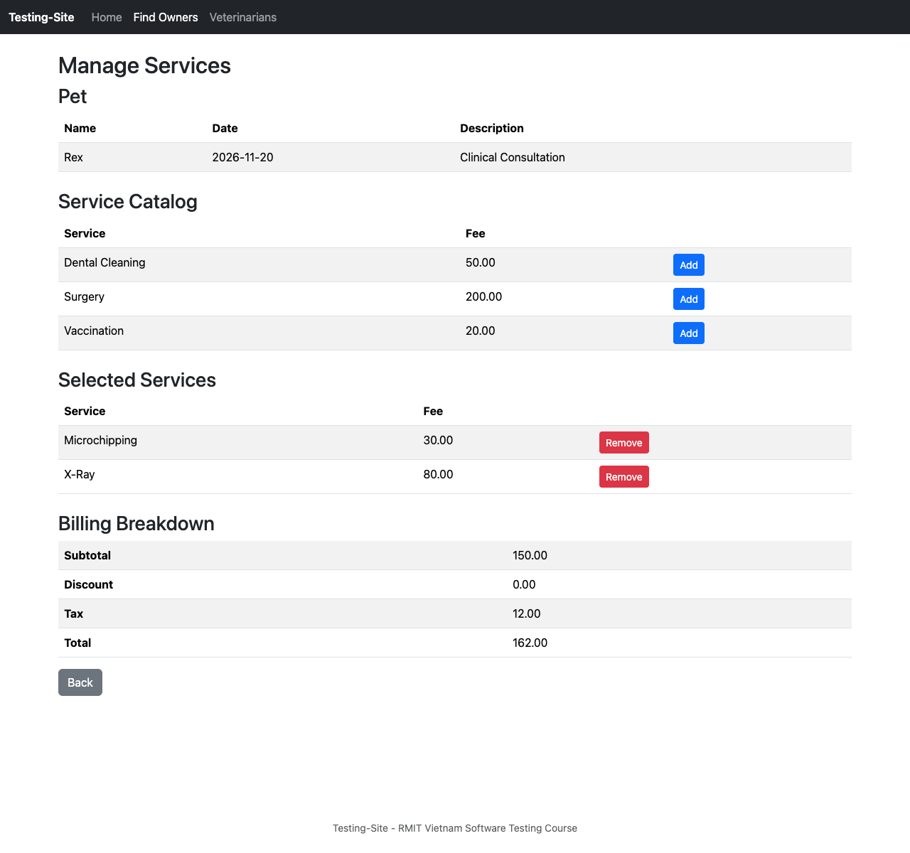  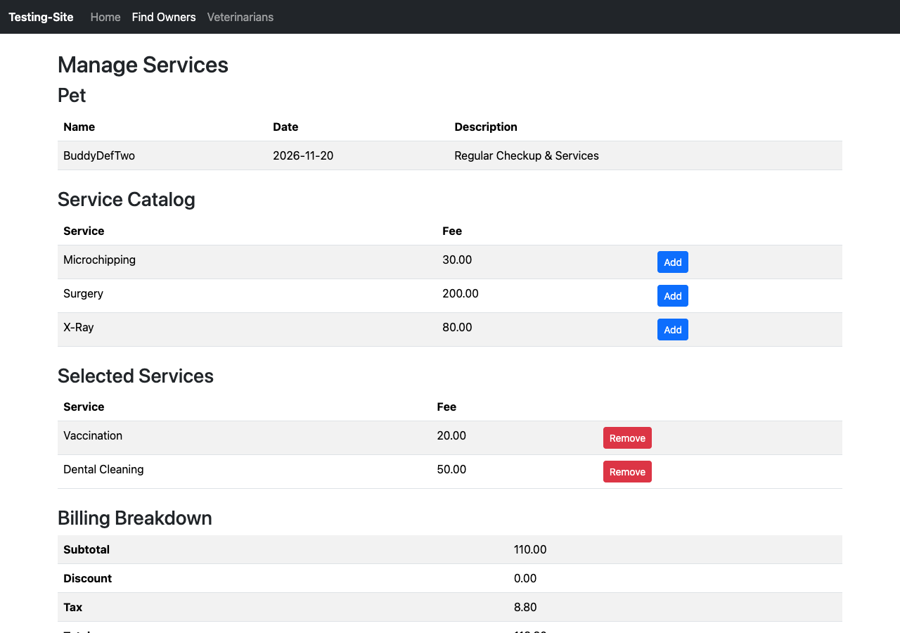  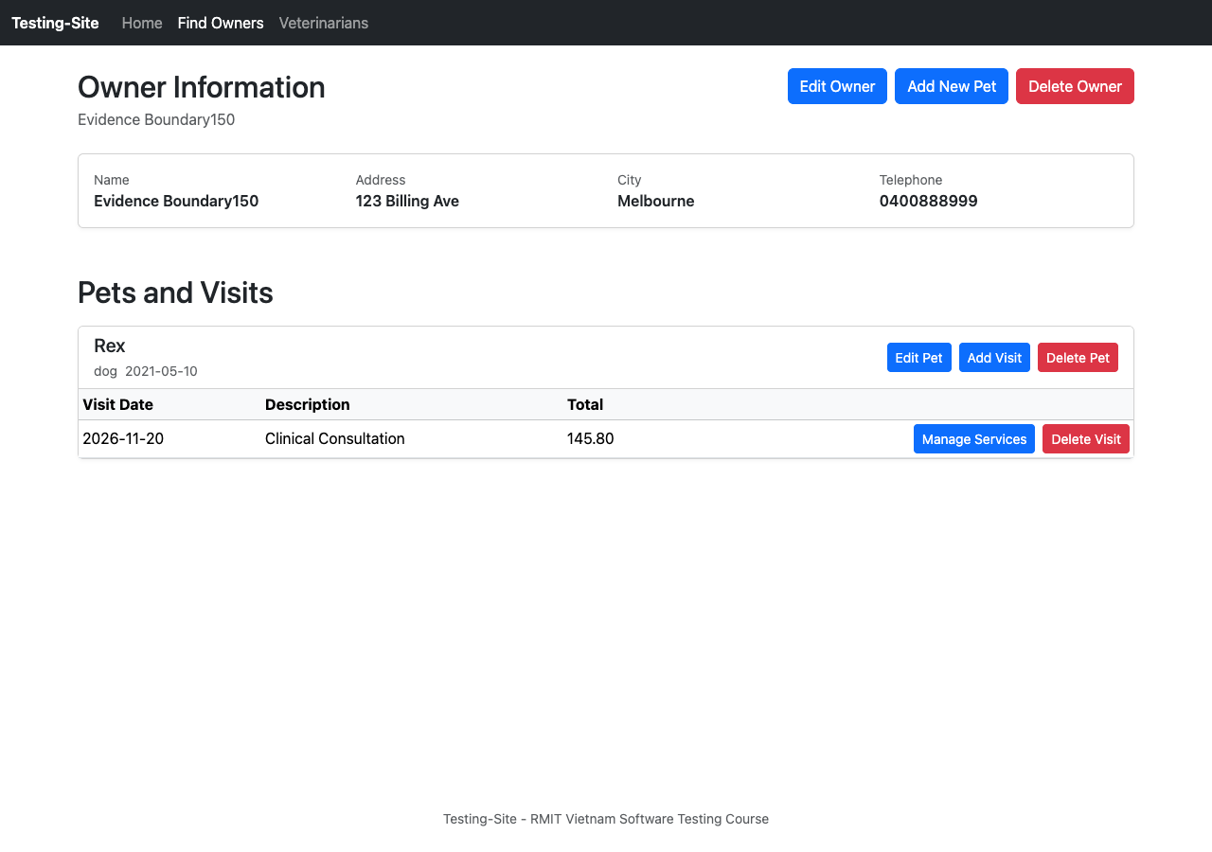  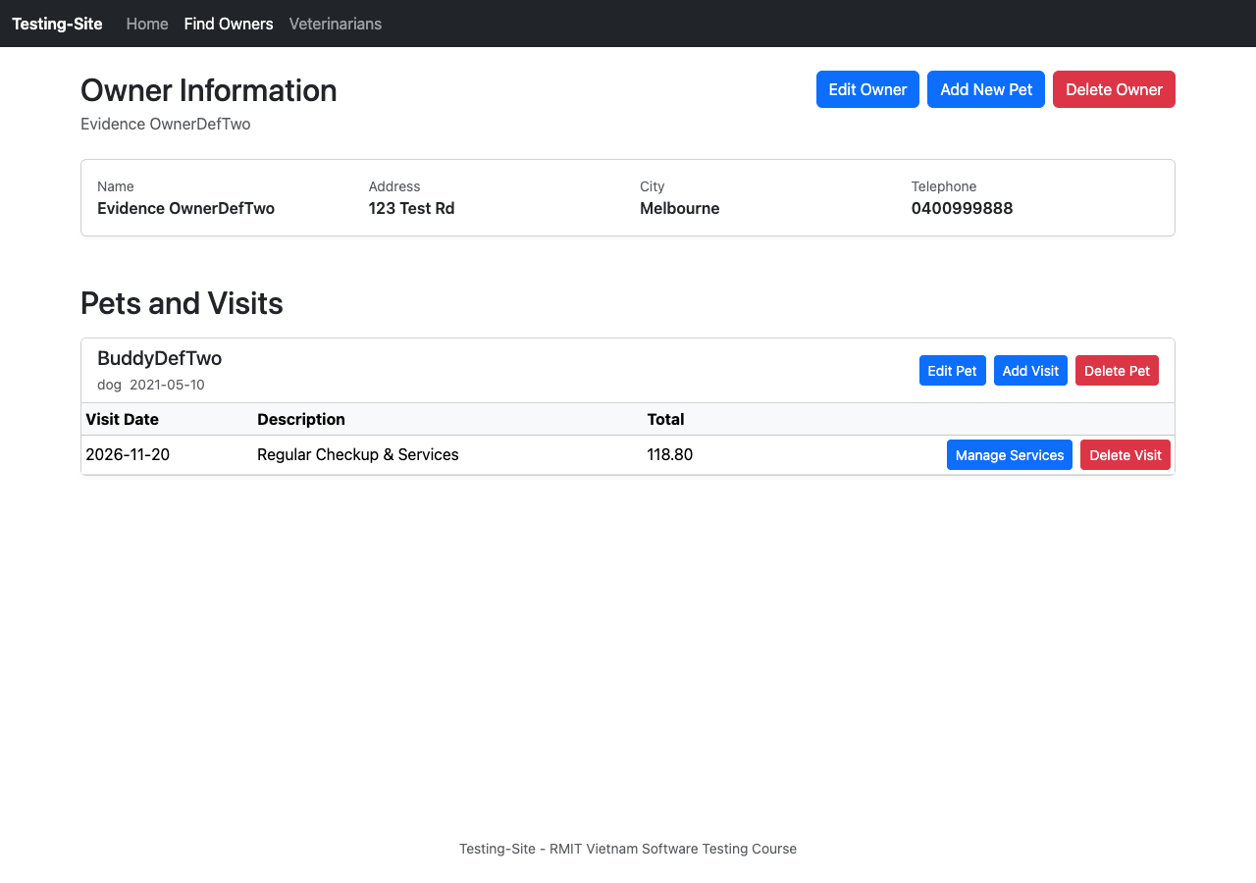
Detecting Test Link | BDD: Include/features/visit_services_billing.feature:15 (Scenario Outline: A visit's total is identical on every screen that shows it, row 2: subtotal $150.00)
Environment | Pet Clinic Release 2.0 (Localhost, Java 17, Chrome 122)
Notes
Table 5.14: DEF-CAL-02: Loyalty discount not applied at exactly 150.00
Defect ID | DEF-CAL-02
Priority / Severity | Priority: Highest | Severity: High
Justification | The system uses > instead of >=, causing incorrect calculations at the discount threshold. This can overcharge eligible loyal customers and violate clinic policy.
Created / Updated | Created 5 Sep 2026 | Last updated 13 Sep 2026
Epic | Billing and Financial Calculations Workflow (SCRUM-48)
Linked Requirement | US-CAL-01 / AC-01, AC-03, AC-04, AC-05 (FR-S4)
Explanation (Impact) | A loyalty discount is not applied when a visit subtotal is exactly 150.00. This causes incorrect billing and affects customer charges and revenue calculations.
Expected Behaviour | • A 10% loyalty discount is applied when the subtotal reaches 150.00.  • Discount: 15.00  • Tax: 10.80  • Total: 145.80
Actual Behaviour | • No discount is applied.  • The total displayed is 162.00.
Steps to Reproduce | - Ensure an owner and pet exist.  - Book a future visit on Pet Clinic Release 2.0.  - Navigate to Manage Services for the visit.  - Add Microchipping (30.00).  - Add X-Ray (80.00).  - Confirm the subtotal is 150.00.
Supporting Evidence | 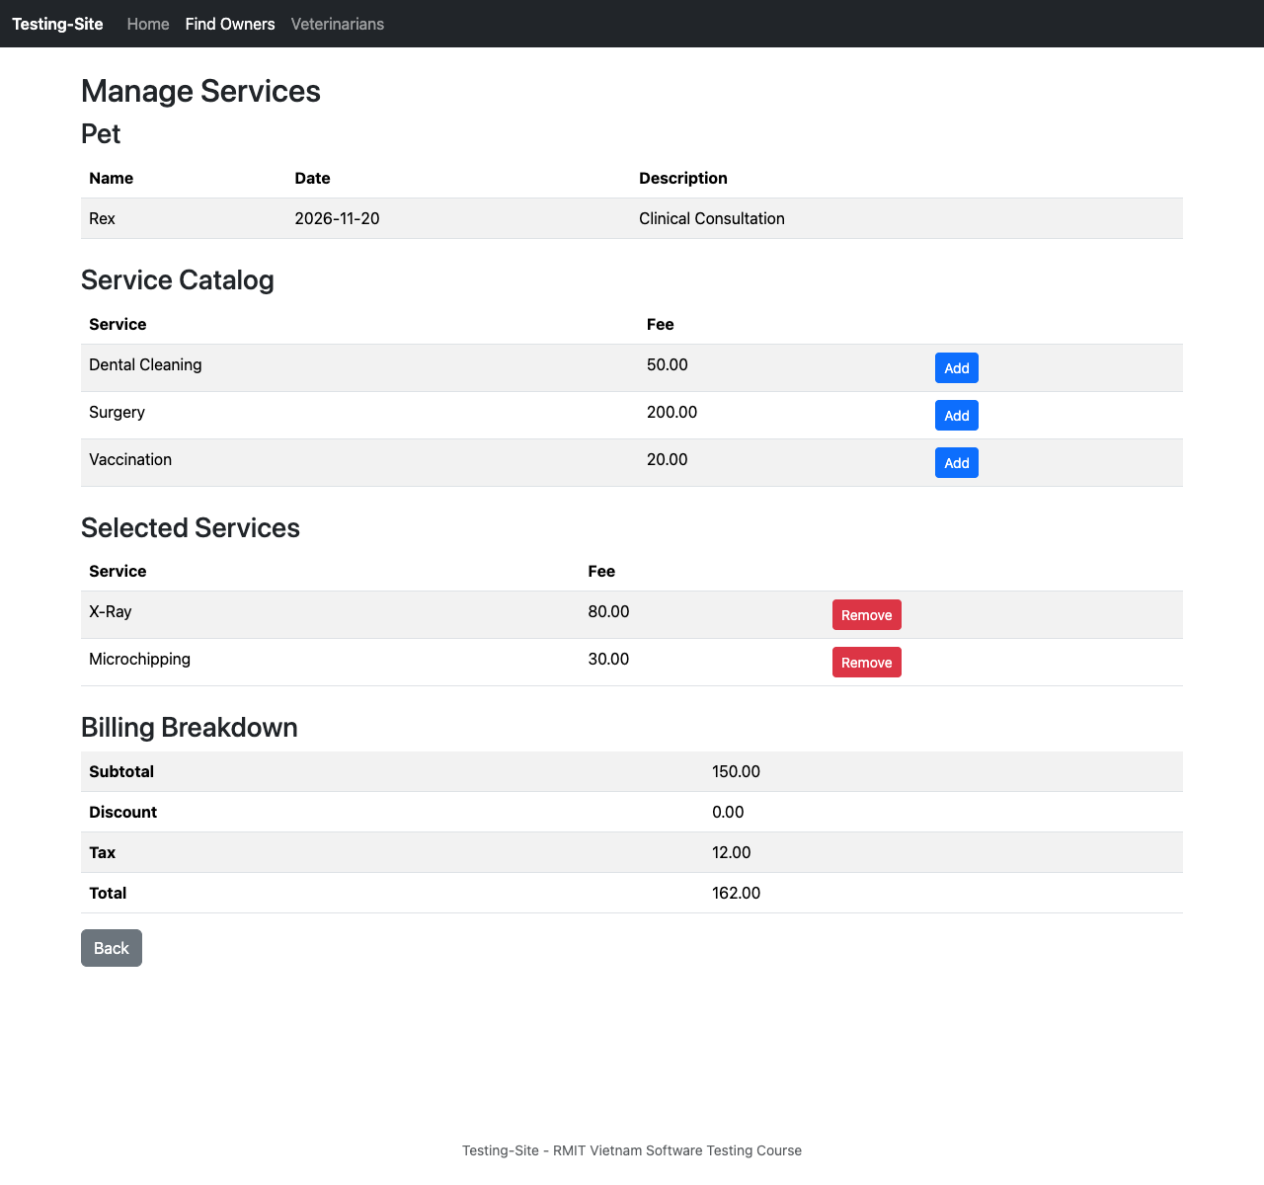
Detecting Test Link | Selenium: src/test/java/tests/billing/VisitServicesBillingTest.java:94 (tcCal02_boundary150SubtotalTriggersDiscount)  BDD: Include/features/visit_services_billing.feature:15
Environment | Pet Clinic Release 2.0 (Localhost, Java 17, Chrome 122)
Notes
Table 5.15: DEF-CAL-03: Tax calculated on pre-discount subtotal instead of post-discount amount
Defect ID | DEF-CAL-03
Priority / Severity | Priority: Highest | Severity: High
Justification | The application calculates tax on the gross amount instead of the discounted net amount. This inflates tax charges and may violate sales tax regulations.
Created / Updated | Created 5 Sep 2026 | Last updated 13 Sep 2026
Epic | Billing and Financial Calculations Workflow (SCRUM-48)
Linked Requirement | US-CAL-02 / AC-01, AC-03, AC-04, AC-05 (FR-S5)
Explanation (Impact) | Users are overcharged when the loyalty discount applies. Tax is calculated on the pre-discount subtotal instead of the discounted amount.
Expected Behaviour | • Add Surgery (200.00), making the subtotal 240.00.  • Apply the 10% discount of 24.00, making the discounted amount 216.00.  • Calculate tax on 216.00 — tax should be 17.28.  • Total should be 233.28.
Actual Behaviour | • Discount is correctly applied as 24.00.  • Tax is calculated on the full 240.00 subtotal instead of 216.00.  • Tax is 19.20.  • Total displayed is 235.20.
Steps to Reproduce | - Ensure the owner and pet exist.  - Book a future visit on Pet Clinic Release 2.0.  - Navigate to Manage Services for the visit.  - Add Surgery (200.00).  - Apply the 10% discount.
Supporting Evidence | 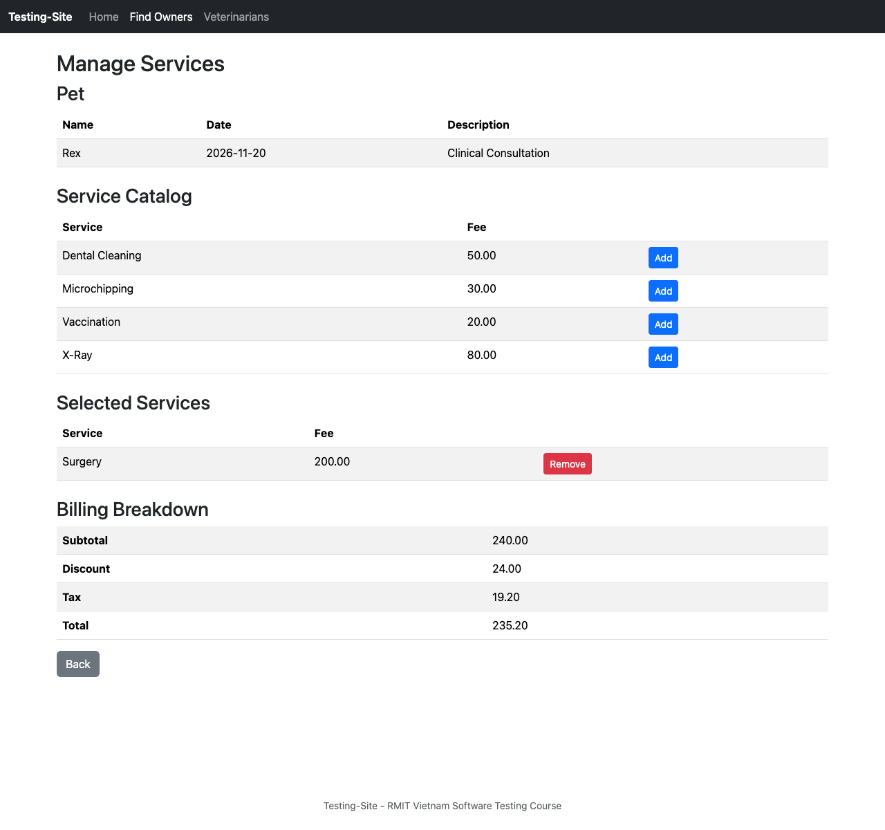
Detecting Test Link | Selenium: src/test/java/tests/billing/VisitServicesBillingTest.java:115 (tcCal05_taxCalculatedOnPostDiscountAmount)
Environment | Pet Clinic Release 2.0 (Localhost, Java 17, Chrome 122)
Notes
Table 5.16: DEF-CAL-04: The billing screen doesn't re-price after removing a service
Defect ID | DEF-CAL-04
Priority / Severity | Priority: Highest | Severity: High
Justification | The UI does not recalculate bill totals after deleting a line item. This can leave cancelled services incorrectly included in the customer’s bill.
Created / Updated | Created 13 Sep 2026 | Last updated 13 Sep 2026
Epic | Billing and Financial Calculations Workflow (SCRUM-48)
Linked Requirement | US-CAL-03 / AC-01, AC-02, AC-03 ( FR-S5)
Explanation (Impact) | If a user removes a service without the price adjusting, the customer may be charged for services they are not receiving, which risks additional cost to the customer and damage to the clinic's reputation.
Expected Behaviour | • Add Vaccination (20.00).  • Add Dental Cleaning (50.00).  • Verify Subtotal = 110.00 (as written in the ticket — see review note).  • Remove Dental Cleaning.  • Verify Subtotal = 60.00 (as written in the ticket — see review note).
Actual Behaviour | • Remove Dental Cleaning.  • Subtotal remains 110.00 — the bill does not re-price.
Steps to Reproduce | - Ensure the owner and pet exist.  - Ensure Dental Cleaning and Vaccination are in the service list.  - Book a future visit.  - Navigate to Manage Services for the visit.  - Add Vaccination.  - Add Dental Cleaning.  - Verify the Subtotal.  - Remove Dental Cleaning.  - Verify the Subtotal.
Supporting Evidence | 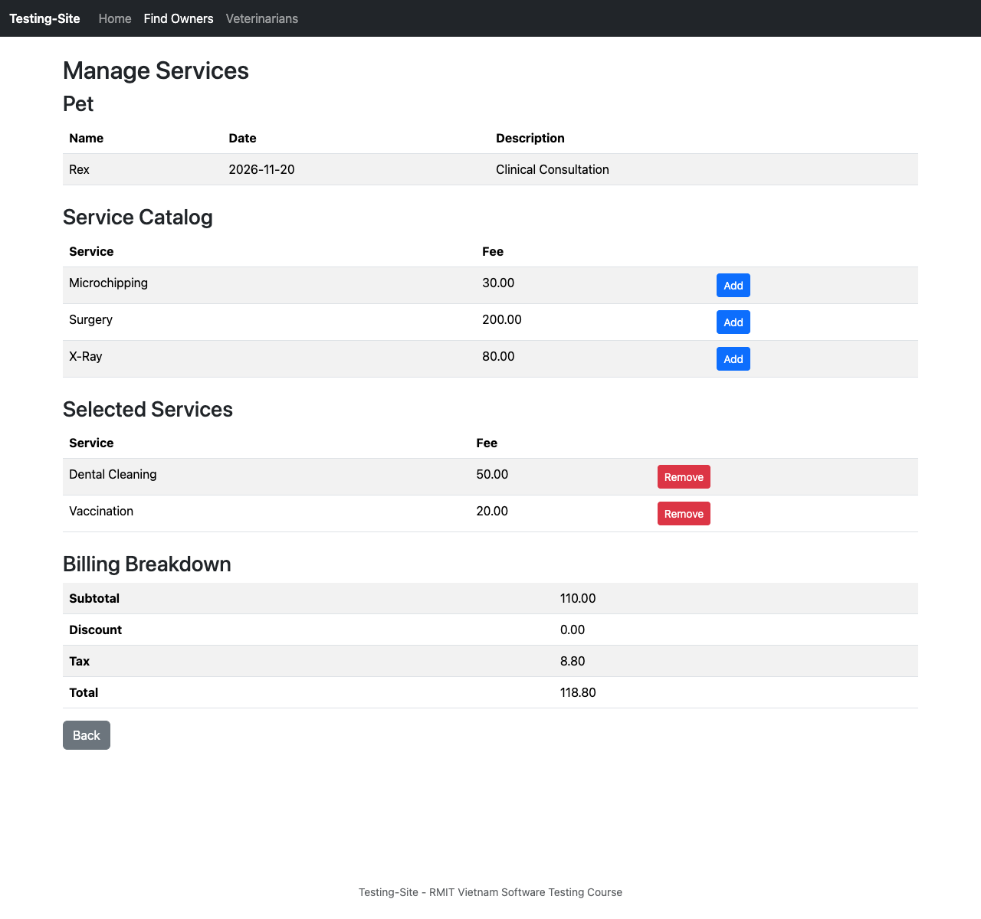  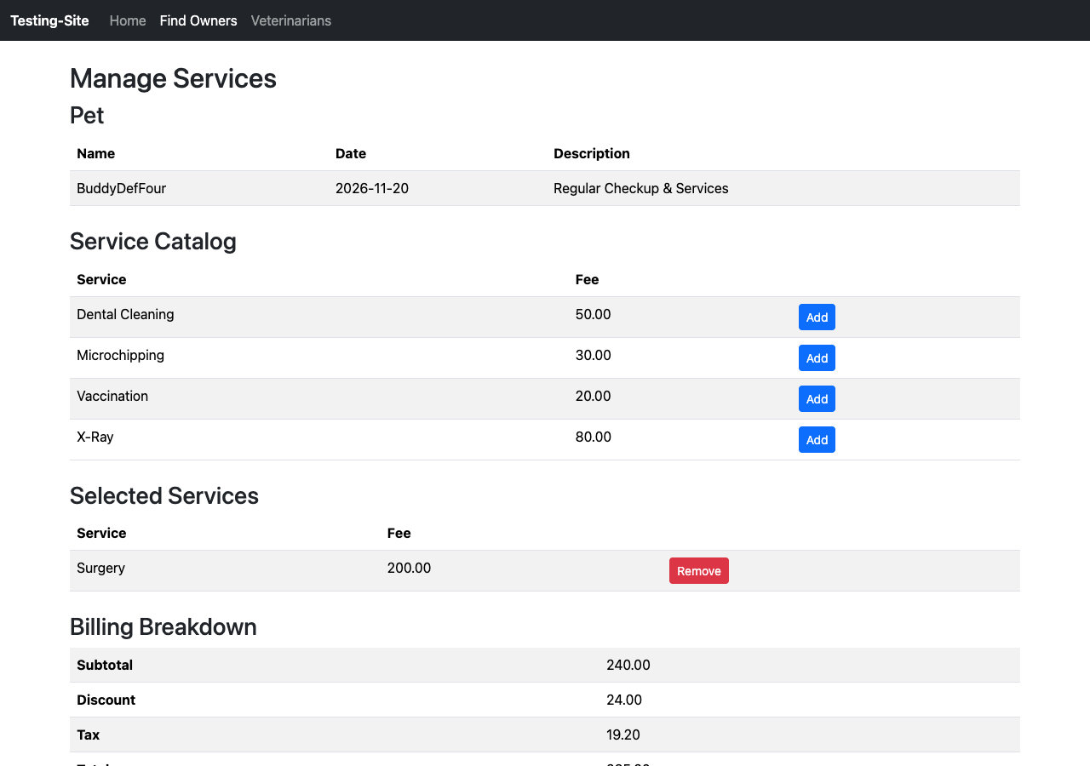
Detecting Test Link | Selenium: src/test/java/tests/billing/VisitServicesBillingTest.java:132 (tcCal07_singleServiceRemovalRecalculation & tcCal10_staleDiscountPurged)  BDD: Include/features/visit_services_billing.feature:28
Environment | Pet Clinic Release 2.0 (Localhost, Java 17, Chrome 122)
Notes
Table 5.16: Full Traceability Matrix
Story | Acceptance Criterion | Test Case | Automation | Defect | Test Owner
US-OWN-01 (SCRUM-82) | AC-01 — 9-digit telephone rejected with validation error | TC-OWN-02 (SCRUM-101)  TC-OWN-05 (SCRUM-104) | OwnerManagementTest  (tcOwn02to04_telephoneValidation,  tcOwn05_blankTelephone) | None | Lam Quang Nhat
 | AC-02 — 10-digit telephone accepted, owner saved | TC-OWN-01 (SCRUM-100) | OwnerManagementTest  (tcOwn01_createOwnerWithValidData) | None | Lam Quang Nhat
 | AC-03 — 11-digit telephone rejected with validation error | TC-OWN-03 (SCRUM-102) | OwnerManagementTest  (tcOwn02to04_telephoneValidation) | None | Lam Quang Nhat
 | AC-04 — non-digit character rejected with validation error | TC-OWN-04 (SCRUM-103) | OwnerManagementTest  (tcOwn02to04_telephoneValidation) | None | Lam Quang Nhat
US-OWN-02 (SCRUM-83) | AC-01 — edit applies the same validation rules as create | TC-OWN-06 (SCRUM-105)  TC-OWN-07 (SCRUM-106)  TC-OWN-08 (SCRUM-107)  TC-OWN-09 (SCRUM-108) | OwnerManagementTest  (tcOwn06_editOwnerSuccess,  tcOwn07_editBlankField) | None | Lam Quang Nhat
 | AC-02 — owner ID in form must match ID in the address | TC-OWN-10 (SCRUM-109) | OwnerManagementTest  (tcOwn10_editOwnerIdMismatch) | None | Lam Quang Nhat
US-PET-01 (SCRUM-7) | AC-01 — valid pet details saved and shown on Owner Details | TC-PET-02 (SCRUM-12) | PetManagementTest  (testDataDrivenAddPet) | None | Caelum
 | AC-02 — blank Name blocked with validation error | TC-PET-03 (SCRUM-13) * | PetManagementTest  (testAddPetWithBlankName) | None | Caelum
 | AC-03 — future birth date blocked with error | TC-PET-04 (SCRUM-14) * | PetManagementTest  (testAddPetWithFutureDate) | None | Caelum
 | AC-04 — pet type selectable from valid dropdown values | TC-PET-02 (SCRUM-12) | PetManagementTest  (testDataDrivenAddPet) | None | Caelum
 | AC-05 — edited pet details reflect immediately | TC-PET-05 (SCRUM-15) * | BDD Acceptance  (pet_management.feature: @TC-PET-05) | None | Caelum
US-VISIT-01 (SCRUM-16) | AC-1.1 — visit dated today rejected (FR-V2) | TC-VISIT-01 (SCRUM-64) | VisitBookingTest  (testBookVisitTodayRejected) | None | Trong Tran
 | AC-1.2 — visit dated tomorrow saved (FR-V2 boundary) | TC-VISIT-02 (SCRUM-65) | VisitBookingTest  (testBookVisitTomorrowAccepted) | None | Trong Tran
 | AC-1.3 — empty description rejected (FR-V3) | TC-VISIT-03 (SCRUM-66) | VisitBookingTest  (testEmptyDescriptionRejected) | None | Trong Tran
US-CAL-01 (SCRUM-93) | AC-01 — discount triggers automatically at 150.00 | TC-CAL-02 (SCRUM-59)  TC-CAL-03 (SCRUM-60) | VisitServicesBillingTest  (TC-CAL-02, TC-CAL-03) | DEF-CAL-02 (SCRUM-111) | Bui Phuong Dong Quan
 | AC-02 — no discount at 149.99 or below | TC-CAL-01 (SCRUM-58) | VisitServicesBillingTest  (TC-CAL-01) | None | Bui Phuong Dong Quan
 | AC-03 — discount amount and percentage displayed | TC-CAL-01 (SCRUM-58)  TC-CAL-02 (SCRUM-59)  TC-CAL-03 (SCRUM-60) | VisitServicesBillingTest  (TC-CAL-01, TC-CAL-02, TC-CAL-03) | DEF-CAL-02 (SCRUM-111) | Bui Phuong Dong Quan
 | AC-04 — displayed total equals the amount the customer pays | TC-CAL-01 (SCRUM-58)  TC-CAL-02 (SCRUM-59)  TC-CAL-03 (SCRUM-60) | VisitServicesBillingTest  (TC-CAL-01, TC-CAL-02, TC-CAL-03) | DEF-CAL-02 (SCRUM-111) | Bui Phuong Dong Quan
 | AC-05 — discount behaves identically on every visit | TC-CAL-01 (SCRUM-58)  TC-CAL-02 (SCRUM-59)  TC-CAL-03 (SCRUM-60) | VisitServicesBillingTest  (TC-CAL-01, TC-CAL-02, TC-CAL-03) | DEF-CAL-02 (SCRUM-111) | Bui Phuong Dong Quan
US-CAL-02 (SCRUM-94) | AC-01 — tax charged on the post-discount amount | TC-CAL-05 (SCRUM-96)  TC-CAL-06 (SCRUM-97) | VisitServicesBillingTest  (TC-CAL-05, TC-CAL-06) | DEF-CAL-03 (SCRUM-112) | Trong Tran
 | AC-02 — tax charged on subtotal when no discount applies | TC-CAL-04 (SCRUM-95) | VisitServicesBillingTest  (TC-CAL-04) | None | Trong Tran
 | AC-03 — screen states which amount tax was calculated on | TC-CAL-04 (SCRUM-95)  TC-CAL-05 (SCRUM-96)  TC-CAL-06 (SCRUM-97) | VisitServicesBillingTest  (TC-CAL-04, TC-CAL-05, TC-CAL-06) | DEF-CAL-03 (SCRUM-112) | Trong Tran
 | AC-04 — final total uses the correctly calculated tax | TC-CAL-04 (SCRUM-95)  TC-CAL-05 (SCRUM-96)  TC-CAL-06 (SCRUM-97) | VisitServicesBillingTest  (TC-CAL-04, TC-CAL-05, TC-CAL-06) | DEF-CAL-03 (SCRUM-112) | Trong Tran
 | AC-05 — same tax method on every visit | TC-CAL-04 (SCRUM-95)  TC-CAL-05 (SCRUM-96)  TC-CAL-06 (SCRUM-97) | VisitServicesBillingTest  (TC-CAL-04, TC-CAL-05, TC-CAL-06) | DEF-CAL-03 (SCRUM-112) | Trong Tran
US-CAL-03 (SCRUM-113) | AC-01 — removed service disappears from Selected Services | TC-CAL-07 (SCRUM-115) *  TC-CAL-09 (SCRUM-117)  TC-CAL-10 (SCRUM-118) | VisitServicesBillingTest  (TC-CAL-07, TC-CAL-09, TC-CAL-10) | DEF-CAL-04 (SCRUM-123) | Bui Phuong Dong Quan
 | AC-02 — subtotal, discount, tax and total recalculate | TC-CAL-07 (SCRUM-115) *  TC-CAL-09 (SCRUM-117)  TC-CAL-10 (SCRUM-118) | VisitServicesBillingTest  (TC-CAL-07, TC-CAL-09, TC-CAL-10) | DEF-CAL-04 (SCRUM-123) | Bui Phuong Dong Quan
 | AC-03 — values redisplay without a page refresh | TC-CAL-07 (SCRUM-115) *  TC-CAL-09 (SCRUM-117)  TC-CAL-10 (SCRUM-118) | VisitServicesBillingTest  (TC-CAL-07, TC-CAL-09, TC-CAL-10) | DEF-CAL-04 (SCRUM-123) | Bui Phuong Dong Quan
 | AC-04 — new values are mathematically correct | TC-CAL-09 (SCRUM-117)  TC-CAL-10 (SCRUM-118) | VisitServicesBillingTest  (TC-CAL-09, TC-CAL-10) | None | Bui Phuong Dong Quan
 | AC-05 — other services remain selected and visible | TC-CAL-09 (SCRUM-117)  TC-CAL-10 (SCRUM-118) | VisitServicesBillingTest  (TC-CAL-09, TC-CAL-10) | None | Bui Phuong Dong Quan
US-CAL-04 (SCRUM-114) | AC-01 — services removable one at a time, each recalculating | TC-CAL-08 (SCRUM-116) | VisitServicesBillingTest  (TC-CAL-08) | None | Trong Tran
 | AC-02 — no cascading errors across sequential removals | TC-CAL-08 (SCRUM-116) | VisitServicesBillingTest  (TC-CAL-08) | None | Trong Tran
 | AC-03 — final bill matches the wanted-services-only bill | TC-CAL-08 (SCRUM-116) | VisitServicesBillingTest  (TC-CAL-08) | None | Trong Tran
US-CAL-05 (SCRUM-119) | AC-01 — Manage Services total matches owner visit history | TC-CAL-11 (SCRUM-120)  TC-CAL-12 (SCRUM-121)  TC-CAL-13 (SCRUM-122) | VisitServicesBillingTest  (TC-CAL-11, TC-CAL-12, TC-CAL-13) | DEF-CAL-01 (SCRUM-110) † | Nguyen Minh Khoi
 | AC-02 — consistency holds regardless of service count | TC-CAL-11 (SCRUM-120)  TC-CAL-12 (SCRUM-121)  TC-CAL-13 (SCRUM-122) | VisitServicesBillingTest  (TC-CAL-11, TC-CAL-12, TC-CAL-13) | DEF-CAL-01 (SCRUM-110) † | Nguyen Minh Khoi
 | AC-03 — owner page shows updated total, no stale cache | TC-CAL-11 (SCRUM-120)  TC-CAL-12 (SCRUM-121)  TC-CAL-13 (SCRUM-122) | VisitServicesBillingTest  (TC-CAL-11, TC-CAL-12, TC-CAL-13) | DEF-CAL-01 (SCRUM-110) † | Nguyen Minh Khoi
US-VET-01 (SCRUM-10) | AC-01 — page lists all veterinarians with their specialties | NO COVERAGE | — (Manual only / Out of Scope) | None | —
 | AC-02 — blank specialty indicator instead of an error | TC-VET-01 (SCRUM-74) | VeterinarianDirectoryTest  (TC-VET-01) | None | Nguyen Minh Khoi
 | AC-03 — page is read-only (no create / edit / delete) | NO COVERAGE | — (Manual only / Out of Scope) | None | —
 | AC-04 — list paginated at 5 items per page | TC-PAGINATION-01 (SCRUM-80) ‡ | OwnerSearchPaginationTest  (TC-PAGINATION-01) | None | Nguyen Minh Khoi
US-SEARCH-01 (SCRUM-43) | AC-01 — search is case-insensitive | TC-SEARCH-05 (SCRUM-79) * | OwnerSearchPaginationTest  (TC-SEARCH-05) | None | Nguyen Minh Khoi
 | AC-02 — non-matching name shows a "not found" error | TC-SEARCH-02 (SCRUM-76) | OwnerSearchPaginationTest  (TC-SEARCH-02) | None | Nguyen Minh Khoi
 | AC-03 — empty search returns the full owner list | TC-SEARCH-01 (SCRUM-75) | OwnerSearchPaginationTest  (TC-SEARCH-01) | None | Nguyen Minh Khoi
 | AC-04 — single match goes straight to owner detail page | TC-SEARCH-03 (SCRUM-77) * | OwnerSearchPaginationTest  (TC-SEARCH-03) | None | Nguyen Minh Khoi
 | AC-05 — multiple matches show a paginated list | TC-SEARCH-04 (SCRUM-78) * | OwnerSearchPaginationTest  (TC-SEARCH-04) | None | Nguyen Minh Khoi
US-PAGINATION-01 (SCRUM-44) | AC-01 — owner and veterinarian lists paginated at 5 per page | TC-PAGINATION-01 (SCRUM-80) *  TC-PAGINATION-02 (SCRUM-81) * | OwnerSearchPaginationTest  (TC-PAGINATION-01, TC-PAGINATION-02) | None | Nguyen Minh Khoi
 | AC-02 — "First" and "Last" navigate to first / last page | TC-PAGINATION-01 (SCRUM-80) *  TC-PAGINATION-02 (SCRUM-81) * | OwnerSearchPaginationTest  (TC-PAGINATION-01, TC-PAGINATION-02) | None | Nguyen Minh Khoi
 | AC-03 — "Previous" and "Next" navigate one page at a time | TC-PAGINATION-01 (SCRUM-80) *  TC-PAGINATION-02 (SCRUM-81) * | OwnerSearchPaginationTest  (TC-PAGINATION-01, TC-PAGINATION-02) | None | Nguyen Minh Khoi
 | AC-04 — clicking a page number navigates to that page | TC-PAGINATION-01 (SCRUM-80) *  TC-PAGINATION-02 (SCRUM-81) * | OwnerSearchPaginationTest  (TC-PAGINATION-01, TC-PAGINATION-02) | None | Nguyen Minh Khoi
Table 6.1: Executive Test Coverage Audit Across Core Functional Areas
Feature Area | Module Owner | Selenium Coverage | BDD Coverage | Performance Coverage
Feature 1: Owner Management | Lam Quang Nhat | 12 methods / 16 runs: valid creation, 4 blank-field checks, name length boundary, parameterized telephone boundary (5 rows), edit success, edit validation, detail view, and 2 defect-detecting checks (OwnerManagementTest) | BDD data tables & boundary analysis (Data Files/Owner*) | Included in JMeter Find Owners and Owner Profile endpoints
Feature 2: Pet Management | Chang Fang Cih (Caelum) | 3 tests / 7 runs: 5-species parameterized test, blank name check, future date check (PetManagementTest) | 5 scenarios: happy path, data-driven outline, blank name, future date, edit (pet_management.feature) | Included in JMeter multi-page flows
Feature 3: Owner Search & Pagination | Tran Vinh Trong | 2 tests: empty search retrieval, multi-page pagination controls (OwnerSearchPaginationTest) | Integrated within Owner test datasets | Profile lookup /owners?lastName= sampler in JMeter
Feature 4: Visit Services & Billing | Bui Phuong Dong Quan | 4 tests: service additions, removal, $150 loyalty discount boundary, 8% tax calculation (VisitServicesBillingTest) | 3 scenarios: date boundaries, billing calculation outline, same-day booking rejection (VisitServicesAndBilling.feature) | Dedicated billing sampler /services in 1, 10, 25, and 50 user thread groups
Feature 5: Veterinarian Directory | Nguyen Minh Khoi | 2 tests: directory loading, specialty badge rendering (VeterinarianDirectoryTest) | Regression verification in test suite | Directory sampler /vets.html in JMeter
Table 6.3: Engagement Exit Criteria Compliance Evaluation
Criterion from Section 1.4 | Target Threshold | Actual Result | Met?
Execution Completeness | 100% of planned tests executed across all three streams. | 14 Selenium tests, 8 BDD scenarios, and 4 JMeter thread groups ran with exported reports. | Yes
Defect Severity Threshold | Zero unresolved Blocker (Sev 1) defects. | No application crashes or data loss bugs encountered. BUG-PET-01 is classified as High (Sev 2). | Yes
Defect Detection Verification | At least one Selenium test and one BDD scenario fail by detecting real specification violations. | Both TC-PET-04 (Selenium) and @TC-PET-04 (BDD) failed, exposing the missing future-date validation. | Yes
Performance Quality Gate | 0% HTTP 5xx errors; error rate < 1.0% under baseline loads (1–10 users). | 0.00% error rate across all load levels, including 50 concurrent users. | Yes
Traceability | 100% of tests and defects map to Jira user stories and acceptance criteria. | All 5 user stories, 5 QAlity test cases, and the logged defect are linked in the traceability matrix. | Yes
Table 7.1: Individual Speaking Roles and Feature Allocation
Speaker & ID | Slot & Duration | Assigned Slides & Domain | Slide Breakdown & Topic | Core Talking Points & Technical Presentation | Technical Q&A Defense Domain
Tran Vinh Trong  s3863973 | 00:00 – 03:00  (3 mins) | Slides 1–3  • Scope & Governance  • Sec 1 & 6.4 Lead | • Slide 1: Title & Overview  • Slide 2: Scope & Assumptions  • Slide 3: Test Strategy | • Sets presentation objectives and client-facing briefing agenda.  • Defines testing scope across 5 modules and key baseline assumptions (ASM-01 to ASM-04).  • Summarizes the 3-stream testing strategy across Selenium, Katalon BDD, and JMeter. | Engagement scope, operational assumptions, overall test strategy.
Bui Phuong Dong Quan  s3975939 | 03:00 – 06:00  (3 mins) | Slides 4–6  • Test Drivers & Findings  • Sec 1.2 & Sec 5 Lead | • Slide 4: Why We Test  • Slide 5: Priority  • Slide 6: What We Found (5 Features) | • Articulates business drivers: preventing financial loss and protecting patient records.  • Explains risk-based testing priority (Billing as Priority 1 Critical, Scheduling as Priority 2).  • Synthesizes execution results across all 5 modules, confirming 100% test completion and intentional defect discovery. | Risk prioritisation rationale, execution metrics, Jira defect workflow.
Nguyen Minh Khoi  s3978862 | 06:00 – 09:00  (3 mins) | Slides 7–8  • Clinical & Billing Failures  • Sec 3 & Sec 6.3 Lead | • Slide 7: What It Means for the Clinic  • Slide 8: Financial & Billing Critical Failures | • Demonstrates front-desk friction caused by BUG-OWN-01 (case-sensitive search missing clients) and BUG-PET-01 (future birth dates).  • Deep dives into DEF-CAL-01 to DEF-CAL-04: $150 loyalty boundary error, 8% tax charged on gross subtotal ($19.20 vs $17.28), and screen total mismatches. | Front-desk usability, patient data hygiene, billing defect mechanics.
Chang Fang Cih (Caelum)  s4073761 | 09:00 – 12:00  (3 mins) | Slides 9–10  • Concurrency & Data Analysis  • Sec 4 & Sec 6.1 Lead | • Slide 9: Performance Findings  • Slide 10: How You Read Them | • Presents JMeter load scaling across 1, 10, 25, and 50 virtual users (0% error rate).  • Interprets performance data: separating JVM warm-up artifacts from the 5.7× search latency spike (p95 = 237.8 ms) at 50 users; explains in-memory HSQLDB limits vs production databases. | JMeter thread architecture, performance data analysis, database concurrency limits.
Lam Quang Nhat  s3980424 | 12:00 – 15:00  (3 mins) | Slides 11–13  • Recommendation & Risks  • Sec 2 & Sec 6.2 Lead | • Slide 11: Final Release Decision  • Slide 12: Residual Risks & Monitoring  • Slide 13: Thank You & Q&A Handover | • Delivers the team's Conditional Release verdict: deploy only after hotfixing P0 billing and search defects.  • Details post-deployment monitoring: APM response time alerts, daily reconciliation jobs, and rollback triggers.  • Concludes formal presentation and opens the floor for client Q&A. | Release criteria, rollback protocols, post-deployment monitoring.
Table 8.1: AI Tool Usage Declaration
Team Member & Student ID | AI Tool & Model Version | Specific Purpose & Prompt Objective | Human Verification & Validation Method
Chang Fang Cih (Caelum)  s4073761 | Google Gemini  (Gemini 3.8 Flash) | Generated initial JUnit 5 parameterized test structure (@ParameterizedTest, @CsvSource) for pet species validation. | Cross-referenced generated pet species against Pet Clinic seed database (types table). Corrected missing fixture setup in generated code.
Lam Quang Nhat  s3980424 | GitHub Copilot  (v1.84) | Auto-completed Page Object Model element locators and getter methods in OwnerPage.java and NewOwnerPage.java. | Inspected generated CSS selectors and XPath expressions against the live DOM in Chrome DevTools. Discarded hallucinated button IDs.
Nguyen Minh Khoi  s3978862 | Anthropic Claude  (Claude 4.6 Sonnet) | Drafted declarative Gherkin scenarios for Katalon Studio BDD feature files (pet_management.feature). | Compared scenario steps against Assignment 1 requirements summary to verify that steps represented business rules rather than UI click sequences.
Bui Phuong Dong Quan  s3975939 | OpenAI ChatGPT  (GPT-5.6 Luna) | Drafted automated Selenium test methods to verify the 10% loyalty discount threshold and 8% tax calculation in VisitServicesBillingTest.java. | Executed generated scripts against running application endpoints. Identified two calculation errors and invalid locator assumptions against requirements FR-S4 and FR-S5.
Tran Vinh Trong  s3863973 | Google Gemini  (Gemini 1.5 Pro) | Wrote the initial bash script (run_advanced_performance.sh) to parameterize JMeter CLI executions and generate CSV summary tables. | Ran script on macOS zsh; adjusted JVM memory flags and corrected CSV column parsing to match JMeter 5.6.3 aggregate output.

